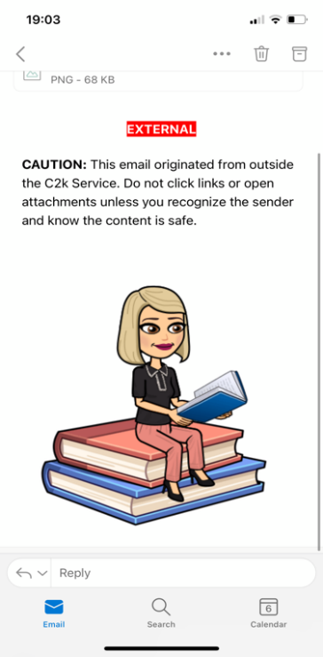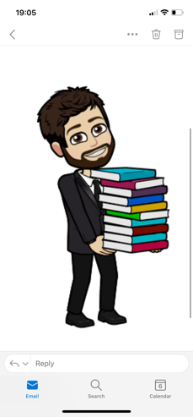

**Literacy**

Reading: We would like to thank you in your support of encouraging your child to read. Please continue to spend some time listening to your child’s reading every night and sign reading record.

Spelling: Weekly spelling tests will continue. It is important in their spelling development to look over these spellings daily.

Writing: we will continue to focus on developing your child’s handwriting and presentation. We would ask that you support your child in this area and encourage them to do neat and tidy work.

**Mathletics**

Children are encouraged to use their individual log-ins to play Mathletics at home to reach their weekly target set that week. Mathletics can be accessed on desktop computers or tablets. Children can also access Mathletics each day once their school work is completed, in order to boost their mathematical fluency.

**Homework**

Please ensure your child’s written homework and homework diary is signed each night, once homework is sent home. Encourage your child to read to an adult and discuss the content of the book and the characters. **Please practise mental maths and spellings each night in preparation for Friday’s tests.**

**Physical Education**

Children should come to school wearing their P.E unform which should consist of yellow polo shirt and navy tracksuit bottoms. Children should wear appropriate trainers for P.E.

**Maths**

This term will focus on continuing to develop pupils’ ability to multiply, divide, add and subtract. We will also look at fractions, time, money and capacity. Children will complete mental maths activities each day and will use practical materials to aid their understanding in their maths topic work.

November

December 2021

Year 5 Newsletter

**Accelerated Reading**

Each child is encouraged to read for pleasure as much as possible in order to develop their inferencing skills. Accelerated Reading will remain a big focus across the school this year. Well done to the children who have already received prizes for AR.

**Reminders**

School is closed for children and staff on Monday 6th December.

If your child is sick, please use the school app or website to report the absence and provide a reason.

**Christmas Holidays:**

School will close on Thursday 23rd December and reopen on Thursday 6th January 2022.