

Monday News 8th December 2025
Date | Time
Mon 8th   | 9.30-12pm  11am | - Last week of Clubs (See below)  - Final Collection day for our Christmas Appeals.  - Dinner Menu: Week 2 (See website for Menu)  - NO Credit Union savings this week- resumes next week  - P7’s Gaelic with Brian Og's (During school)  - P4 & P5 Fire Safety talk (During School)  P6 Swimming (10wks)  Whole School Mass (P2-P7). Families welcome to attend (P6 will attend swimming)
Tues 9th | 9.30-12 Noon | - P1 football with Ballymoor FC (During School-Every Week)  - P2 – Musical Pathways (During School every week)  - Foyle College & Lumen Christi College to visit P6 & P7 pupils  - P5 STEM Workshop- during School  Nursery, P1 & P2 to visit SCC Santa Experience
Wed 10th | 9.30-10.50am  1.45pm | - Please ensure you have returned Panto Permission & £5  - P5 Hurley with Na Magha (During school- Every Wk)  - St Josephs School to visit P7 boys  P3, SPIMS 1 & 2 to visit SCC Santa Experience  Choir to sing at Oakleaf Care Home.
Thurs 11th |  |   - P4 & P5: Mandarin Lessons (During school- Every Wk)  - Christmas Dinner & Jumper Day
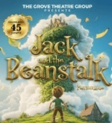  Fri 12th |   9.15-12.30pm | - ‘Breakfast Club Special’ – Every Friday  P1 – P7, SPIMS 3 to attend Jack & the Beanstalk Pantomime  Nursery, SPIMS 1 & SPIMS 2- Parky the Magician to visit
Afterschool Clubs
All After School clubs finish Thursday 11th December, except for P1 & P2 Afterschool Club & Wraparound which run until Thursday 18th December.
All Clubs resume Mon 5th January.

Christmas Events at Steelstown P.S & Nursery Unit
un 14th Dec | 12.15pm | P4 ‘Do this in Memory’ Mass. Gaudete Sunday
Mon 15th Dec |   11am | Carol Service. Our Lady of Lourdes Church. Everyone Welcome
Tues 16th Dec | 9am-12pm  11am  1pm |   P7 Girls – St Mary’s College  Nursery Christmas show  P1 Christmas Show (Details to follow)
Wed 17th Dec | 10am  6pm | P1 Christmas Show (details to follow)  P4 Christmas Show (Evening) (More details to follow)
Thurs 18th Dec | 10am | P4 Christmas Show (Morning) (More details to follow)
Fri 19th Dec |  | Non-Uniform Day  Lunch & 12.30pm finish for all pupils
Mon 22nd Dec – Sun 4th Jan | 
Mon 5th Jan 2026 | All pupils return to school
Wed 7th Jan 2026 | Open day for Nursery & P1 pupils – Sept 2026
Nursery ‘Big Bedtime’ Read
Thank you to everyone who attended our Nursery ‘Big Bedtime Read’.
The boys and girls had a wonderful time listening to stories and enjoying their bedtime books together.
📚 A big thank you to our amazing Nursery staff for organising such a special event for our children.
🍪 Thank you also to Collette in our canteen for the freshly baked goodies that made the evening even sweeter.

Christmas Appeals
Thank you to everyone who has already donated to our Christmas appeals, we appreciate your generosity as always.

Final Day for donations is Monday 8th December.
Any support you can offer will be deeply appreciated by the ETHOS team, Foyle Food Bank and the families they help. Thank you for your continued support.

Ethos Family Support Hub Christmas Toy Initiative
Donations, vouchers, or items from the wish list below
Wish List:
- Babies and young children (0-7): Toys / Books / Games
- Older children and young people (8-18): Toiletries / Pyjamas / Make-up / Vouchers (Xbox/PlayStation/Amazon)
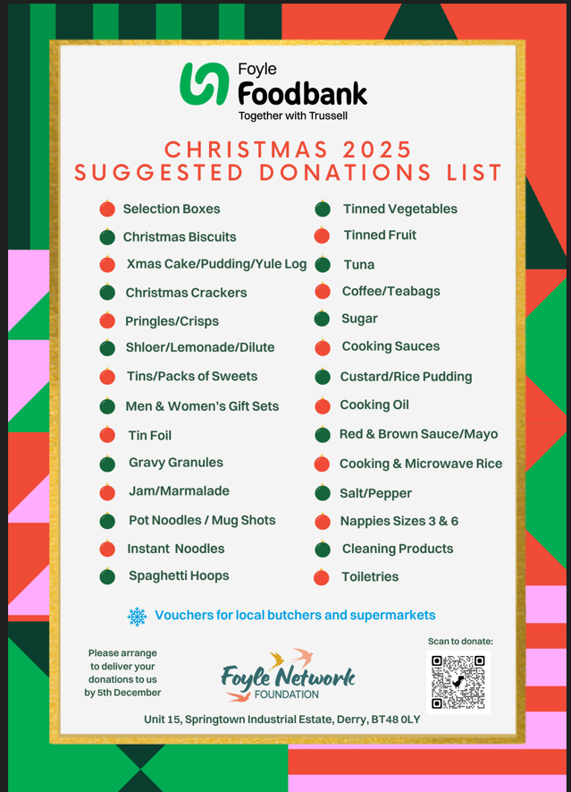
Christmas Pantomime
All children in Y1-Y7 & SPIMS 3 will attend ‘Jack & the Beanstalk’ pantomime in St Columb’s Hall on Fri 12th Dec. The cost of the trip is £5 per child, the remainder will be subsidised by the school.
All children have received a permission slip, please complete & return to your child’s class teacher. Children must wear full school uniform, bring a coat, treat & a drink. Reminder: Please do not send items containing Nuts/some Popcorn can contain traces of Nuts.
Nursery children, SPIMS 1 & SPIMS 2 classes will have a visit from Parky the Magician.


NSPCC
Thank you to Gavin Campbell from NSPCC for delivering the Listen Up, Speak Out campaign to our parents. It was an informative and engaging session that highlighted the importance of safeguarding and keeping children safe.
A big thank you to all our parents who continue to work in partnership with us to create a safe and supportive environment for every child. Together, we are building a community where every child feels heard, valued, and protected.
Please see links below to the NSPCC online safety resources and a link to the NSPCC learning site.
https://www.nspcc.org.uk/keeping-children-safe/online-safety/
https://www.nspcc.org.uk/keeping-children-safe/online-safety/free-online-safety-group-workshops/
Https://learning.nspcc.org.uk/

Nursery & P1 Open Day
Steelstown Primary School & Nursery Unit Open day will take place on Wed 7th Jan from 3.30-5pm. Please share with family & friends who have children enrolling for school next September. We look forward to meeting everyone.
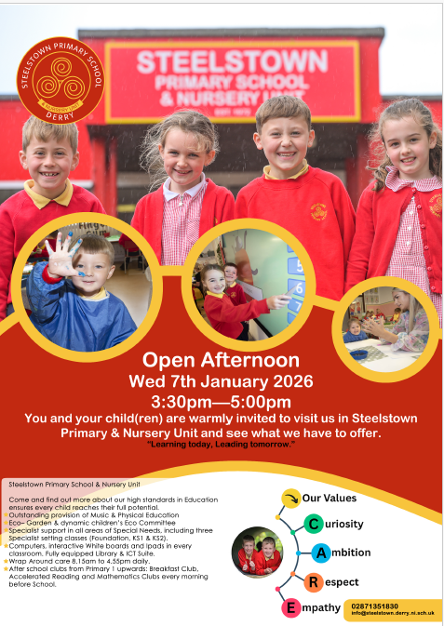
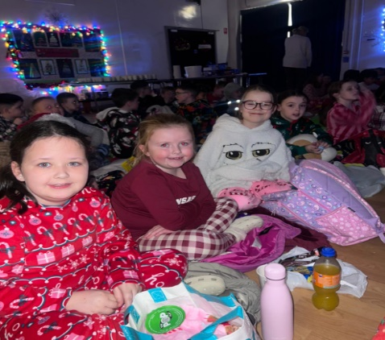
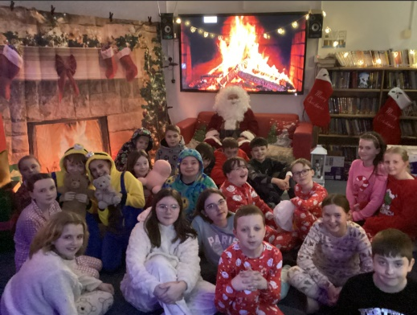
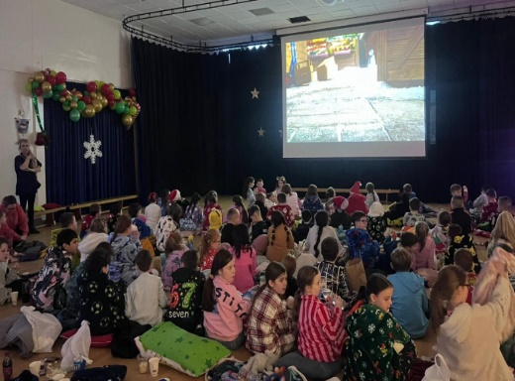
Christmas Movie Night

