Monday News 9th February 2026
Dates for your Diary

***SCHOOL CLOSED Mon 9th to Fri 13th Feb – Mid-Term Break ***
All pupils return Mon 16th Feb
Mon 16th Feb | ***New Dinner Menu ***Week 1 Dinner Menu  (Please note change to Menu on Mon & Wed this week due to Ash Wednesday)  Credit Union savings – give pouch to class teacher  P6 Swimming lessons- During school  Brian Ogs Gaelic – P7’s, 5C, P3’S - During School
Tues 17th Feb | P2- Musical Pathways- Every Week- During School  SPIMS 3: Musical Therapy (GSAP) - During School Week 4/4  9.15am – 1.30pm: Nursery Trip to Century Play, Letterkenny
Wed 18th Feb | (Please note change to Menu on Mon & Wed this week due to Ash Wednesday)  Ash Wednesday Prayer Service during school for all pupils  P7 & P5 – Na Magha- Hurley – Every Week -During School
Thurs 19th Feb | P4 & P5 – Mandarin Lessons – Every Week – During School  12 Noon: Online Applications close for Post Primary School
Fri 20th Feb | 8.15 – 9am: ‘Breakfast Club Special’ Day . Every Friday  9.10am: Mr Feeney’s P7 Class Assembly. Families welcome to attend
Sun 22nd Feb | 12.15pm: P4 DTIM Mass – First Sunday of Lent
Tues 24th Feb | P4 First Communion Preperation session- During school  9.15-1.30pm: Nursery to visit Shantallow Community Centre  11.20 – 1.30pm: P5 to attend Storytelling in Guildhall
Wed 25th Feb | Netabll Team Competition – Foyle Arena- During school
Fri 27th Feb | 8.30 – 10am: Coffee Morning in Canteen in aid of Daibhin’s chosen charity ‘ICU’.  Autism NI ‘Superhero Day’  9.10am Mrs McGlinchey’s P5 Class Assembly. Families welcome to attend
Thurs 5th Mar | World Book Day
Fri 3rd – Mon 13th Apr | Easter Holidays- All pupils finish at 12.30pm on Thursday 2nd Apr.  Mon 13th- Staff Development Day.  All pupils return Tuesday 14th Apr
Sat 16th May | 12 Noon: P4 First Holy Communion – Our lady of Lourdes Church

P7 Confirmation
Congratulations to all our Primary 7 pupils who received the Sacrament of Confirmation. We are extremely proud of you and this significant step in your faith journey.
A heartfelt thank you to Monsignor Donnelly for leading a beautiful service.
We also extend our gratitude to Mr. Feeney, Mrs. E O'Donnell, and all our dedicated Primary 7 staff for preparing the children so well. Your hard work truly shines through!
A special thank you to Mrs O’Doherty & our wonderful choir, under the direction of Mrs. R O'Donnell, for enhancing our ceremony with your beautiful music.
Lastly, we want to thank the families and the Steelstown Community for coming together to create such a beautiful, prayerful ceremony. We will continue to keep our Primary 7 pupils in our prayers as they move forward in their faith.

Staff Development Days
The Department of Education have allocated schools two Staff Development Days. Pupils do not attend on these days. Our first development day is Mon 13th April. All pupils return to school on Tuesday 14th April.
Second Staff Development date to be confirmed.


Just2Easy
Please ensure you have logged in & activated the parent portal for your childs Just2Easy account (This is serperate to the login your child has inside their homework diary- this is for their use). This is our main means of communication between the school and parents and is used to share important information and updates & incase of emergencies/late notices.
ParentPay
Please esnure your ParentPay account is in credit with payments for Dinners, P1 & P2 Afterschool Club, Wraparound Care & Swimming.
Post Primary Applications
The admissions criteria for Post Primary applications is now available to view on the EA website www.eani.org.uk
Thursday 19th February @ 12 Noon: EA Connect closes for online applications for Post Primary Applications Sept 2026.

Number Day/’Dress for Digits’ Day
Well done to all our boys & girls who celebrated NSPCC ‘Dress for Digits Day’ by wearing Numbered clothing. Thank you for all your donations to help support such worth causes.
Thank you for your support.



World Book Day
Steelstown P.S & Nursery Unit will celebrate World Book Day on Thursday 5th March. We would like all children to come to school dressed as their favourite book character. We do not want this day to be an added expense so look for costumes that you already have & recycle or do a swap with friends.
If you have any unwanted costumes which may be suitable, we would be delighted to have them to share with others.
Battery Recycling
Please encourage your child to recycle any old batteries at our battery recycling box at reception. #ecoschool
Internet Safety
Please see letter sent by Mrs O’Neill on Just2Easy regarding Mobile Phones.
We kindly ask parents/guardians to complete the short survey.
Thank you for your support.

Thank you from Foyle Food Bank
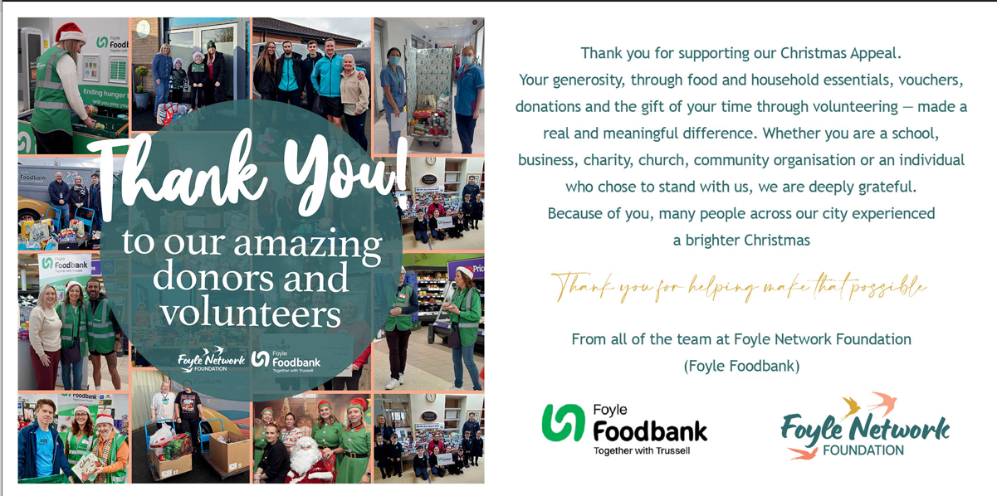
Dinner Menu
New Dinner menu runs from 16th Feb to 30th June.
Please note change to Week 1 menu on Mon 16th & Wed 18th February only.
