STEELSTOWN PRIMARY SCHOOL & NURSERY UNIT

Addressing Bullying Policy



Implementation of the policy will take place after consultation with the Board of Governors in 2026. This policy will be reviewed every year/2 years by the PDMU Co-Ordinator, the VP, the Board of Governors and Staff. The next review date is 2028.

Signature of Chair of Board of Governors 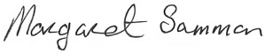
Signature of Principal: 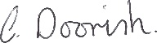

It is a duty placed on Boards of Governors in Northern Ireland, to ensure the school has an effective Addressing Bullying Policy and practices aligned to the Addressing Bullying in Schools (NI) Act 2016 which commenced in schools September 2021.

This Addressing Bullying Policy takes account of key legislation and is informed by DE Guidance, EA/CCMS publications and the international context (Appendix 1).

 | Date | Signatures
Consultation (Staff, Pupils, Parents etc)  key issues identified:  Key changes include: | 20/1/26 -26/1/26  No issues identified |   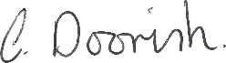
Ratification | 26/1/26
Next consultation/review date: | 26/1/28

Contents:
Section 1: Statutory Context & Guidance
- Introduction
- Ethos & Values
- Links to other policies
- Consultation
Section 2: What is bullying type behaviour?
- Legal definition and TRIP criteria explained
- Language
- Journey to and from school
- Electronic Communication
Section 3: Methods and Motivations
Section 4: Rights, Roles and Responsibilities explained.
Section 5: Preventative Measures.
- Preventative Measures explained
- Professional Development of Staff
Section 6: Statutory Systems and Processes for reporting, responding, and recording.
- Pupil(s) reporting a bullying type of concern
- Parent(s)/Carer(s) reporting a bullying type of concern
- Responding to and recording a bullying type of concern
Section 7: Monitoring and Review of the Addressing Bullying Policy.
Appendices:
- Legislative Context & Guidance links
- Statutory Process Flowchart
- Bullying Concern Assessment Form (BCAF) template
- Effective Responses to Socially Unacceptable/Bullying Type Behaviour
- Rights, Roles & Responsibilities Table
- EA ABSIT Parent & Pupil Guides to Addressing Bullying Type Behaviour
- Board of Governors Reporting Pro-forma

Section 1: Statutory Context & Guidance
Introduction
At Steelstown Primary School, we acknowledge that bullying type behaviour exists in schools and wider society and can impact on the lives, mental health, and well-being of those involved. This policy aims to help create, maintain, and embed a culture where everyone agrees that bullying type behaviour is unacceptable.

At Steelstown Primary School, we believe that safeguarding our pupils is paramount and the responsibility of all stakeholders. We promote a safe, inclusive, and relational school environment where concerns of bullying type behaviour may be shared and addressed, and where pupils are supported within the context of Article 19 Measures to Prevent Bullying, Education (NI) 2003 and the 2016 Addressing Bullying in Schools Act (N.I.) (see appendix 1).

The purpose of this policy is to:
- define bullying type behaviour
- summarise rights, roles and responsibilities
- explain preventative measures
- clarify processes used for reporting, recording, and responding
- outline monitoring and review processes

The policy is applied where concerns of alleged bullying type behaviour between pupils have been reported. For other concerns regarding bullying type behaviours please refer to the school complaints procedures or associated policies which are aligned DE Circular 2016/08 Public services ombudsman (NI) Act).

Ethos and Values

The ethos of the school is central to the establishment and maintenance of good behaviour. The school seeks to emphasise and regard positive behaviour rather than apply sanctions. Factors essential in promoting good behaviour include:

(a) The Curriculum - quality, relevance, pupil grouping, teaching methods, record keeping and assessment procedures are all means by which teachers can reduce potential for bullying in class through effective class management.
(b) The Pastoral System – is supportive of pupils, proactive in developing programmes such as Circle time, buddy system, friendship stops and citizenship rather than relying on reactive management when things go wrong.
(c) The Ethos – relies on the quality of relationships between teachers themselves and between teachers and pupils to encourage an openness designed to allow pupils to speak out where problems are perceived.

It is a primary aim of Steelstown Primary School that every member of the school community feels valued and respected, and that each person is treated fairly and well. We are a caring community, whose values are built on mutual trust and respect for all. The school’s behaviour policy is therefore designed to support the way in which all members of the school can work together in a supportive way. It aims to promote an environment in which everyone feels happy, safe and secure. If this is followed, condemnation of bullying is both implicit and explicit. The belief is promoted that reporting bullying is not ‘taletelling’ but safeguarding others and the vast majority of pupils thus become a positive force in the protection of the individual by giving support to the victim and advising the bully to stop. Incidents should be reported in the knowledge that they will be taken seriously and dealt with both effectively and consistently. It is the aim within Steelstown Primary School to create an atmosphere of mutual respect where good behaviour is a necessary condition for effective teaching and learning to take place.

We at Steelstown Primary School recognise the uniqueness of every pupil and celebrate the diversity of all children and young people within our community.
Therefore:
We are committed to a society where children and young people can live free and safe from bullying type behaviour.
- We believe that every child and young person should be celebrated with their diversity.
- We are committed to a preventative, relational and restorative ethos.
- We value, respect and consider the views and contributions of children, young people and wider school community.

Links to Other Policies
This policy should be read in conjunction with SEND, Safeguarding, Inclusion, and the wider suite of Pastoral Care policies available on the school website or from the school office by request. These policies include but are not limited to:
Safeguarding and Child Protection Policy | Staff Code of Conduct/Staff Handbook
Pupil Attendance Policy | (Positive) Behaviour Policy
Health and Safety Policy | Online Safety Policy
Special Educational Needs Policy | Educational Visits Policy
Relationships and Sexuality Education | Pastoral Care Policy
Equality and Inclusion | Visitor Policy

Consultation
We value and respect the views and contributions of our school community. Therefore, as part of this policy development and review, and in compliance with Article 19 of the 2003 Education (NI) Order and the 2016 Addressing Bullying in Schools Act (N.I.), we have consulted with pupils, parents/carers, and staff.
- Pupil consultation involved – Survey/Class PowerPoint with discussion/ School council feedback.
- Parents & carers consultation – sharing of draft on school website and encouraged to share their opinions.
- Staff – sharing of draft, staff meeting and encouraged to share their opinions.
Section 2: What is Bullying Type Behaviour?
‘The Addressing Bullying in Schools Act (N.I.) 2016’ provides schools with a legal definition which must be used by all schools to assess reported concerns of bullying type behaviour.
Addressing Bullying in Schools
Definition of “bullying”
(1) In this Act “bullying” includes (but is not limited to) the repeated use of—

(a) any verbal, written or electronic communication,
(b) any other act, or
(c) any combination of those, by a pupil or a group of pupils against another pupil or group of pupils, with the intention of causing physical or emotional harm to that pupil or group of pupils.

(2) For the purposes of subsection (1), “act” includes omission.

TRIP
While the legal definition, as set out in the Act, is the primary definition, we also use the mnemonic TRIP. This helps to build a shared understanding across our school community of the difference between socially unacceptable and bullying type behaviour.

Socially unacceptable behaviour becomes bullying type behaviour when, after clarifying facts and perceptions, TRIP is confirmed:

T | When the behaviour is TARGETED at a specific pupil or group of pupils.
R | When the behaviour is REPEATED over time.
I | When the behaviour is deliberately INTENDED to cause harm.
P | When the behaviour causes PSYCHOLOGICAL/EMOTIONAL and/or PHYSICAL harm.

Although incidents usually involve repetition, a one-off incident may be classified as bullying type behaviour through consideration of the following criteria.
- severity and significance of the incident (See appendix 4)
- evidence of pre-meditation
- psychological/physical impact of the incident on the individuals and/or wider school community
- previous relationship(s) between those involved.
- any previous incident(s) involving the individuals.
- A one-off electronic communication can constitute bullying type behaviour through repeated viewing and unwanted sharing of a post.

Any incidents which are not considered bullying behaviour will be addressed under the Positive Behaviour Policy.

The 2016 Act requires school to consider whether a pupil(s) intended to cause harm when determining if the incident(s) meets the legal definition. In this school, we will consider the following when assessing TRIP.
The pupil(s):
- capacity to regulate and understand the impact of their behaviour
- developmental age
- additional, educational, special, physical, or medical needs
- behaviours displayed/presenting profile (diagnosed or undiagnosed e.g. Social Behaviour Emotional Wellbeing, Autism, Attention Deficit Hyperactivity Disorder, Moderate Learning Difficulties etc.)
- individual circumstances e.g. trauma profile, safeguarding concerns, family circumstances and resilience
Omission will be considered when addressing bullying type concerns. This is where a pupil(s) is or are wilfully excluded from a game, activity or group work etc causing potential psychological harm. Pupils do not have to be friends in this school, but friendly.
Language
We recognise that all behaviour is communication and should be addressed through a learner centred lens for those who display and experience socially unacceptable or bullying type behaviour. We will address all behaviour in a relational, solution focused manner aligned to Safeguarding and SEND.
When discussing allegations of bullying type behaviour, we use language that is aligned to the Addressing Bullying in Schools Act (NI) 2016, and other relevant legislation and guidance (see appendix 1). We refer to the behaviour not the pupil and use the following:
- pupil displaying bullying type behaviour rather than the ‘bully’.
- pupil experiencing bullying type behaviour rather than the ‘victim’.
- socially unacceptable behaviour rather than ‘bad behaviour’ or ‘serious/gross misconduct etc’
Any incident(s) which do not meet the legal definition and TRIP criteria will be addressed under the Positive Behaviour, Special Educational Needs, Child Protection, Safeguarding, Pastoral and Inclusion and Diversity policies. (Please see the parent and pupil guides in appendix 6).
Journey To and From School
The Act outlines a statutory requirement for schools to implement measures to prevent and address bullying type behaviour for pupils whilst travelling to and from school. To this end, in our school we:

- Development of a culture where pupils take pride in their school and are viewed as ambassadors for Steelstown Primary School within the community. This includes regular reminders of the positive behaviour expectations of pupils whilst travelling to and from school.
- Regular engagement with transport providers to ensure effective communication and the early identification of any concerns.
- Promotion of key anti-bullying messages and awareness of behaviour expectations of pupils amongst the local community (e.g., local shops, residents, etc.
- Appropriate deployment of staff to support the transition from school day to journey home.

Electronic Communication
The Addressing Bullying in Schools Act enables school to take steps to help prevent and address online bullying type behaviour involving registered pupils during term time. We acknowledge that negative online behaviour occurring either in or out of school hours, can harm a pupil’s education and emotional well-being, and we will support affected individuals. At Steelstown Primary School we are committed to supporting our pupils to use the internet safely, responsibly, and respectfully.

The Addressing Bullying Policy is one of several school policies that address electronic behaviour and are reviewed in response to technological developments. As such, follow up is aligned to the wider policy suite.

In Steelstown Primary School, we aim to prevent electronic bullying type behaviour by:
- Addressing key themes of electronic online behaviour and risk through curriculum content.
- Engaging with statutory and voluntary sector agencies and resources (e.g. Safeguarding Board NI, PSNI, Public Health Agency, Safer Schools App) to support the promotion of key messages and online safe digital use.
- Participating in Safer Electronic/Online/Cyber Campaigns to promote key messages.
- Addressing reported safeguarding concerns in relation to the misuse of electronic communication and provide timely support and intervention.
- Ensuring all staff regularly have on-line safety training
Section 3: Methods and Motivations of Socially Unacceptable or Bullying Type Behaviour
The following are methods of socially unacceptable behaviours which, when targeted, repeated, intentional and causing psychological/physical harm, may be considered as bullying type behaviour:

Physical Acts | Physical - negative physical contact, material harm such as damaging or taking possessions without permission
Verbal or Written acts | Verbal or written - unpleasant comments, written, verbal, gestures.
Social/Relational | Negatively influencing the actions of others to cause psychological or physical harm
Omission  (Exclusion) | Excluding someone/others from e.g. game, activity, group work etc
Electronic Acts | Misuse of online platforms or other electronic communications to cause psychological upset
(Please note the list is not exhaustive)

Our school acknowledges various motivations for bullying type behaviour which we address through our preventative curriculum and responsive approaches. This includes all identity or prejudice motivated bullying type behaviour related to those characteristics protected through Section 75 of the Northern Ireland Act 1998. Motivations include but are not limited to:

- Ability  - Age  - Appearance  - Child Looked After (CLA)/Care experienced  - Community background  - Cultural  - Disability  - SEN  - Family circumstances | - Economic Status/FSM  - Gender/Gender identity/Perceived Gender  - Newcomer/Migrant Status  - Peer relationship breakdown  - Political affiliation/sectarianism  - Race  - Religion  - Sexual orientation

Section 4: Rights, Roles and Responsibilities
In this school, we believe that all members of our school community have the right to be educated in a safe, supportive, learning environment. We acknowledge that all members of our community have a role to play and responsibility to prevent and address bullying type behaviour.

Staff have been assigned specific responsibility within their role for oversight of the implementation of the Addressing Bullying Policy and associated practices aligned to Safeguarding and SEND legislation. They will support the Principal and Board of Governors with the ongoing review processes.

Insert systems flow chart e.g. Vice Principal (Pastoral Care), Designated Safeguarding Team, SBEW Lead, and LSC/SENCO
Section 5: Preventative Measures

The Addressing Bullying in Schools Act (N.I.) 2016, requires schools to focus on preventative measures to help reduce bullying type behaviours. The focus of this section is to set out the approaches taken by our school to help prevent bullying type behaviour effectively.

In Steelstown Primary School we scaffold and promote a positive, relational learning environment where all members of the school community feel safe, included and valued. Our preventative measures help avoid bullying type behaviour and contribute to support plans for pupils. They are evident in all domains of school life and include, but are not limited to:

Whole School  - SEND, Addressing Bullying, Positive Behaviour, Safeguarding, Pastoral Care, Inclusion & Diversity policies  - Visible school ethos e.g. essential agreements, displays, visual cues, celebrations, positive expectations  - Positively framed, agreed and communicated Rights, Roles & Responsibilities for all school community members  - Peer/Student Leadership Teams  - Adults modelling self-regulation, inclusive language and positive relationships  - Restorative Practice approaches embedded through staff training and complimentary resources  - School of Sanctuary  - Trauma Informed and Nurture Principles  - Celebration of diversity, equity and inclusion  - Parent education e.g. workshops, newsletters, leaflets etc  - Shared education projects, events, assemblies, key campaigns e.g. Rights Respecting School kindness day, anti-bullying week, World Mental Health Day, Odd Sock Day etc  - Wellbeing assessment data | Classroom  - Curriculum: PDMU/PATHS/RSE  - Structured class-meeting time to promote belonging, connection and positive relationships  - Cross-curricular activities  - E-safety and digital citizenship  - Social Emotional Learning  - Circle-time/connect and nurture strategies  - Physical/sensory environment regulation checklists  - Relevant literature and resourcing exploring related concepts and themes e.g. empathy, inclusion, diversity, problem-solving, relationships, resilience etc.  - Social thinking/skills training programmes  - Strengths Based Approaches  - Collaborative Learning/Problem Solving and Conflict Resolution  - Online apps and resources  - Roots of Empathy
Non-Classroom  - Supervision and transition arrangements e.g. including buses  - Buddy strategies  - Social and extra-curricular opportunities  - Professional Development/Training  - Structured Play  - Play/art and other therapeutic approaches  - Designated safe/quiet/calm/reflective/nurture  /activity zoned spaces  - Enhanced structure during unstructured times e.g. breakfast club, jobs, lunchtime clubs, homework clubs  - Structures to facilitate reporting concerns e.g. confidential wellbeing reporting link, concern boxes etc | Peer Support  - Student Leadership e.g. Student Council, pupil wellbeing teams, Eco committee, Library Monitors, Digital Leaders etc  - Pupils trained and supported by staff regarding roles, responsibilities  - Peer mentoring programme  - Pupil led/directed extra-curricular activities  - Buddy Schemes  - Children in P7 working with children in FS

Professional Development of Staff
In Steelstown Primary School, we recognise the need for effective, updated, and ongoing training for all staff within our preventative measures. As such, we are committed to:

- ensuring that all staff and Governors complete relevant Safeguarding, Child Protection, SEND and Addressing Bullying in Schools training, including those provided by the Education Authority.
- reviewing and amending the content of the Addressing Bullying Policy following training, complex case review or as directed by Department of Education.
- keeping and regularly updating continued professional development records.

To this end:
- Key leadership staff have completed EA Addressing Bullying in Schools leadership training.

Section 6: Statutory Systems and Processes for Reporting, Responding and Recording.

As a school we recognise that reporting a concern of bullying type behaviour can be difficult. For this reason, we have systems in place to enable pupils, parents, and any other person to share concerns discreetly and efficiently with a trusted adult. All concerns of bullying type behaviour will be responded to in line with legislative processes as outlined in this policy.

Pupils Reporting a Concern:

Pupils may report bullying type concerns in the following ways:

- Verbally sharing with a staff member
- Placing the concern in the ‘Worry Box’

All pupils are encouraged to share concerns regarding socially unacceptable or bullying type behaviour that they experience, display or witness. They should not view this as ‘telling’ but rather ‘talking about concerns’ with the emphasis on ‘getting help’.

Parents/Carers or Others Reporting a Concern:
- In the first instance, all bullying concerns should be reported to the Class Teacher.
- Where the parent is not satisfied that appropriate action has been taken to prevent further incidents, or where further incidents have taken place, the concern should be reported to the Vice-Principal, Mrs O’Neill.
- Where the parent is not satisfied that appropriate action has been taken by the Vice Principal to prevent further incidents, or where further incidents have taken place, the concern should be reported to Principal, Mrs Doorish.
- Where the parent/carer remains unsatisfied that the concern has not been appropriately responded to, the school’s complaints procedure should be followed. This usually involves making a formal, written complaint, to the Chair of the Board of Governors.

While a report of a bullying concern is most likely to come from pupils or their parents/carers, the school will be open to receiving such reports from others not directly involved with the school. Any report of a bullying concern received from pupils and/or parents/carers will be responded to in line with this policy and feedback will be made to the person who made the report. However, it must be noted that no information about action taken in relation to a pupil can be disclosed to anyone other than the pupil and his/her parents/carers.

Responding to and Recording a Bullying Type Concern

It is the responsibility of all staff (including teachers, teaching assistants, wider support staff, office staff, supervisors etc) to report any bullying type of behaviour concerns. All allegations of bullying type behaviour will be responded to using the Statutory Process Flowchart (see appendix 2), recorded digitally on a Bullying Concern Assessment Form (BCAF) Chart (see appendix 3) and stored on the school data management system

Upon receipt of a concern of bullying type behaviour, designated staff will:

- Clarify facts and perceptions.
- Check records and previous assessments (SIMS)
- Collaboratively assess the incident using the T.R.I.P. criteria (Record on BCAF Part 1).

Where bullying type behaviour has been confirmed and in consultation with pupils involved and their parents/carers. Designated staff will ensure that parts 2-4 of the BCAF are completed will:

- Identify methods and potential motivating factors (Record on BCAF Part 2).
- Identify relevant level of support and intervention (Levels 1-4).
- Select appropriate support and interventions (see appendix 4) for all pupils involved (Record on BCAF Part 3a for the pupil experiencing and 3b for the pupil displaying).
- Ensure selected approaches are aligned to and in the context of wider safeguarding, SEND, Equality and diversity, and positive behaviour policies.
- Implement, track, monitor and record effectiveness of supports and interventions (BCAF Part 3).
- Review outcome of interventions (Record on BCAF Part 4).
- Select and implement further interventions as necessary.
- Based on the level of progress, revisit BCAF Parts 3a and 3b or proceed to case closure.

Recording
The school will centrally record all relevant information related to reports of bullying concerns, including:
- how the bullying behaviour was displayed (the method)
- the motivation for the behaviour
- how each incident was addressed by the school
- the outcome of the interventions employed

Records will be kept securely on the online SIMS which is part of the C2k system in schools. Access to these records will be restricted and only provided to appropriate members of school staff. All records will be maintained in line with relevant data protection legislation and guidance and will be disposed of in line with the school’s Retention and Disposal of Documents Policy. Collated information regarding incidents of bullying and alleged bullying behaviour will be used to inform the future development of anti-bullying policy and practice within the school.

Professional Development of Staff
We are committed to ensuring that staff are provided with appropriate opportunities for professional development as part of the school’s ongoing Continued Professional Development (CPD) provisions. CPD records will be kept and updated regularly.

Please note details of support and intervention plans cannot be disclosed to anyone other than that pupil and their parents/carers.

Section 7: Monitoring and Review of Policy

The Act places responsibility on the Board of Governors, in consultation with the principal, to monitor the effectiveness of the Addressing Bullying Policy. To this end, the Board of Governors will:

- maintain a standing item on the agenda of each meeting of the Board where a report on recorded incidents of bullying will be noted.
- identify trends and priorities for action.
- assess the effectiveness of strategies aimed at preventing bullying behaviour.
- assess the effectiveness of strategies aimed at responding to bullying behaviour This Anti-Bullying Policy will be reviewed, in consultation with pupils and their parents/carers, on or before.

The Addressing Bullying Policy will be reviewed in consultation with all school community stakeholders:
- at intervals of no less than four years
- following any complex incident which highlights the need for such a review,
- when reviewing other associated policies, such as the Safeguarding Policy and the Positive Behaviour Policy
- in response to a recommendation by the Education and Training Inspectorate
- following new guidance as directed by the Department of Education.

Appendix 1:
The Legislative Context:
Anti-discrimination laws applicable in Northern Ireland (Equality Commission, 2024)
The Addressing Bullying in Schools Act (Northern Ireland) 2016
Public Services Ombudsman Act (Northern Ireland) 2016
The Children’s Services Cooperation Act (Northern Ireland) 2015
The Education (School Development Plans) Regulations (Northern Ireland) 2010
The Special Education Needs and Disability Order (Northern Ireland) 2005
The Special Educational Needs and Disability Act (Northern Ireland) 2016 https://www.legislation.gov.uk/nia/2016/8/contents
The Education (Northern Ireland) Order 1998
The Education and Libraries Order (Northern Ireland) 2003 (A17-19)
The Northern Ireland Act 1998 Section 75
The Human Rights Act 1998
The Children (Northern Ireland) Order 1995
The Health and Safety at Work Order (Northern Ireland) 1978

The Policy & Guidance Context
Implementing Trauma Informed Approaches in Northern Ireland and Executive Summary (QUB and SBI, 2024)
CCEA Relationships and Education Resource Guidance (2024)
ETI Safeguarding Proforma (ETI, 2023)
Nurture Group Provision Guidance for Schools (DE, 2023)
Draft Consultation: Consultation on the Statutory Guidance On The Reduction And Management Of Restrictive Practices In Educational Settings In Northern Ireland (DE, 2023) DE, DoH & DoJ
Children and Young Peoples Emotional Health and Wellbeing in Education Framework (DE, 2021) DE/DoH
A Life Deserved: Caring for Children and Young People in Northern Ireland (DOH and DE, 2021)
Suspensions and Exclusions for Pupils in Northern Ireland (DE Circular, March 2021)
Model Equality and Inclusion Policy and Guidance (EA, 2020)
Resource File for Children with Special Educational Needs (DE, 2020)
Guidance on Identifying and Supporting Learners with Social, Emotional and Behavioural Difficulties (CCEA, 2020)
Mental health care systems (SBNI, 2019)
The Addressing Bullying in Schools Act (Northern Ireland) 2016 Statutory Guidance for Schools and Boards of Governors (DE, 2019)
Putting Care into Education (DE, 2018)
Safeguarding and Child Protection in Schools: A Guide for Schools (DE, 2017)
Safeguarding Board for Northern Ireland Policies and Procedures (SBNI, 2017)
Co-operating to Safeguard Children and Young People in Northern Ireland (Dept. of Health, Social Services and Public Safety, 2016)
Miss School = Miss Out Improving Pupil Attendance Strategy (DE, 2016)
Pastoral Care in School: Promoting Positive Behaviour (DE, 2001)
Every School a Good School DE 2009 https://www.education-ni.gov.uk/articles/every-school-good-school-esags

The International Context
United Nations Convention on the Rights of the Child (UNCRC)
To:
- Be protected from all forms of physical or mental violence, injury or abuse, maltreatment or exploitation (A,19)
- Be protected from discrimination (A, 2)
- Express their views, in a supported and accessible way, on issues that affect them, and to have their opinions taken seriously (A.12);
- Education. (A.28)

Appendix 2: Statutory Process Flowchart
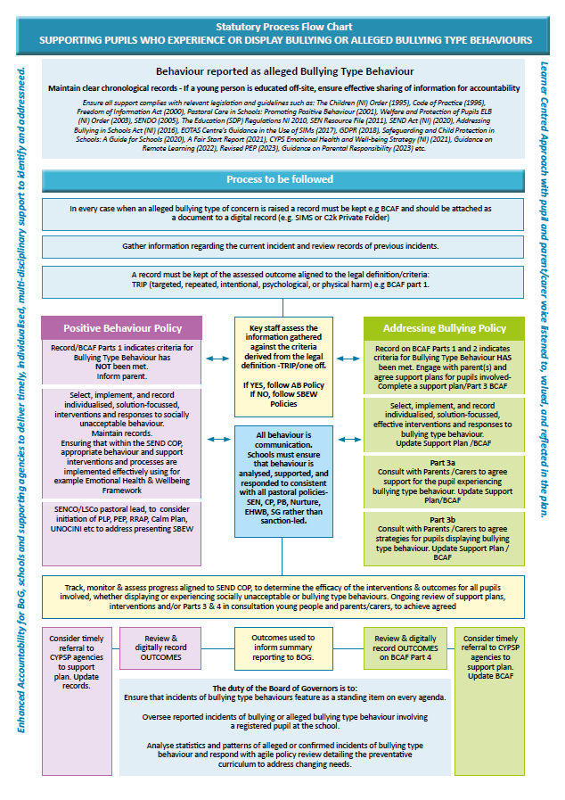
Appendix 3: Bullying Concern Assessment Form (BCAF)
Incident Date:
Pupils Involved | Role | Incident Date | Gender | DOB | Year and Reg

Incident | Comments
Bullying Concern

PART 1 - Assessment of Concern Date:

Addressing Bullying in Schools Act (Northern Ireland) 2016 defines bullying as follows:

“bullying” includes (but is not limited to) the repeated use of —
(a) any verbal, written or electronic communication
(b) any other act, or
(c) any combination of those,
by a pupil or a group of pupils against another pupil or group of pupils, with the intention of causing physical or emotional harm to that pupil or group of pupils.

 | Name(s) | Gender | DOB/Year Group
Person(s) reporting concern

Name of pupil(s) experiencing alleged bullying type behaviour

Name of Pupil(s) demonstrating alleged bullying type behaviour

Check records for previously recorded incidents

Outline of incident(s): Attach all written accounts/drawings of incident(s) completed by pupil(s) experiencing, displaying, witnessing (i.e. other pupils, staff) including date(s) events, SIMS record.
Date | Information gathered | Location (stored)

Socially unacceptable behaviour becomes bullying type behaviour when, based on the information gathered, the criteria listed below have been met:
The school will treat any incident which meets these criteria as bullying type behaviours.
Is the behaviour intentional? | YES / NO
Is the behaviour targeted at a specific pupil or group of pupils? | YES / NO
Is the behaviour repeated? | YES / NO
Is the behaviour causing physical or emotional harm? | YES / NO
Does the behaviour involve omission? (*may not always be present) | YES / NO

One-off Incident

When determining whether a one-off incident may be classified as bullying type behaviour, the school shall take into consideration the following criteria and use the information gathered to inform and guide the decision-making process:

Criteria: | Information gathered:
severity and significance of the incident
evidence of pre-meditation
Significant level of physical/emotional impact on individual/s
Significant level of impact on wider school community
Status/nature of previous relationships between those involved
Records exist of previous incidents involving the individuals

YES, the above criteria have been met and bullying type behaviour has occurred. | NO, the above criterial have not been met and bullying type behaviour has not occurred.
The criteria having been met, proceed to complete Part 2 of this Bullying Concern Assessment Form | The criteria having not been met, proceed to record the details. Refer to the Positive Behaviour Policy of your school, continue to track and monitor to ensure the behaviour does not escalate.
Agreed by ___________________________
Status ____________________________
On ___/___/___

PART 2

2:1 Who experienced this behaviour?
Select one or more of the following:
Individual to individual 1:1 Individual to group Group to individual Group to group
2.2 In what way did the bullying type behaviour present?

Select one or more of the following:

Physical (includes for example, jostling, physical intimidation, interfering with personal property,
punching/kicking
Any other physical contact which may include use of weapons)
Verbal (includes name calling, insults, jokes, threats, spreading rumours)
Indirect (includes omission, isolation, refusal to work with/talk to/play with/help others)
Electronic (through technology such as mobile phones and internet)
Written
Other Acts
Please specify:__________________________________________________-

2.3 Motivation (underlying themes): this is not a definitive list

Select one or more of the following:

Age
Appearance
Cultural
Religion
Political Affiliation
Community background
Gender Identity
Sexual Orientation
Family Circumstance (pregnancy, marital status, young carer status)
Looked After Status (LAC)
Peer Relationship Breakdown
Disability (related to perceived or actual disability)
Ability
Pregnancy
Race
Not known
Other ______________________________________________________________

Part 3a

RECORD OF SUPPORT AND INTERVENTIONS FOR PUPIL EXPERIENCING BULLYING TYPE BEHAVIOUR:
Pupil Name: Year Group/Class:
REFER TO SCHOOL ADDRESSING BULLYING POLICY AND TO LEVEL 1-4 INTERVENTIONS IN EFFECTIVE RESPONSES TO BULLYING TYPE BEHAVIOUR
Parent/ carer informed: Date: By whom:

Staff Involved:

Date | Stage on Code of Practice | Intervention | Success Criteria | Action taken by whom and when | Outcomes of Intervention | Review

Record of participation in planning for interventions
Pupil:

Parent/carer:

Other Agencies:

Continue to track interventions until an agreed satisfactory outcome has been achieved
RECORD OF SUPPORT AND INTERVENTIONS FOR PUPIL DISPLAYING BULLYING TYPE BEHAVIOUR:
Part 3b
Pupil Name: Year Group/Class:
REFER TO SCHOOL ADDRESSING BULLYING POLICY AND TO LEVEL 1-4 INTERVENTIONS IN EFFECTIVE RESPONSES TO BULLYING TYPE BEHAVIOUR
Parent/ carer informed: Date: By whom:

Staff Involved:
Date | Stage on Code of Practice | Type of Intervention | Success Criteria | Action taken by whom and when | Outcome of Intervention | Review

Record of participation in planning for interventions
Pupil:

Parent/carer:

Other Agencies:

Continue to track interventions until an agreed satisfactory outcome has been achieved
PART 4 - REVIEW OF BULLYING TYPE CONCERN AND ACTIONS TO DATE
Date of Review Meeting:
4a- Following the Review Meeting, to what extent have the success criteria been met?
1 – Fully
2 – Partially
3 – Further intervention/support required
Give details: ___________________________________________________________________________________________________________________________________________
Part 4b- If the success criteria have not been met, continue to:
Re-assess Level of Interventions and implement other strategies from an
appropriate level
Track, monitor and review the outcomes of further intervention
Keep under review the Stage of Code of Practice each pupil is on
Follow Safeguarding Policy
Seek multi-agency input (EA, Health and Social Services etc.)
Engage with Board of Governors
Agreed by: Signed by: Date:

Appendix 4: Effective Responses, Support, and Intervention Levels 1 & 2
This list is not exhaustive and supports implemented are specific to each individual pupil.
Level 1: Interventions at Level 1 are designed to support pupils experiencing and/or displaying socially unacceptable or bullying-type behaviours. These interventions should be taken forward while listening to, supporting, and strengthening relationships with and between the pupils involved.  - Schedule a solution focussed meeting with parents/carers of the child experiencing or displaying  - Review SEND CoP and the potential requirement for PLP to address needs e.g. SBEW, ASD, MLD, ADHD  - Refer, align and link to existing support plans e.g. Pupil Learning Plan (PLP), Risk Reduction and Action Plan (RRAP), Risk Assessment and Management Plan (RAMP), Child Looked After Personal Education Plan (PEP) etc  - Explore the concept of bullying type behaviour through resources e.g. ABSIT Information Leaflets and High Five resources  - Co-create, agree, and implement a Calm Plan focused on identifying signals of dysregulation and any potential triggers  - Co-create, agree, and implement a Seeking Help Plan (ERtBB)  - Complete and/or review additional assessments to build a picture of SBEW needs e.g GL PASS, Boxall  - Use of specific verbal cues, affective statements e.g. High Five Journal  - Use visual reminders of positive expectations  - Explore friendship as a concept  - Develop social skills/stories and additional emotional literacy sessions  - Enhance structure during unstructured time e.g. clubs, jobs, supervised safe spaces, zoned areas, breakfast clubs etc.  - Explicitly teach positive expectations  - Explore additional opportunities to build empathy and kindness e.g. High Five Resources, Roots of Empathy, Restorative Approaches, Hopeful Minds  - Use play, art, or other therapeutic approaches  - Make alternative arrangements for travelling to and from school (ERtBB)  - Play group games to encourage positive interactions and inclusion  - Create activities, clubs, and events to grow social communication skills  - Review specific incident using ABC (Antecedent, Behaviour, Consequence) chart  - Review transition planning and pupil support across phases, year groups, schools  - Use 'Circle of Friends’ activity (ERtBB)  - Use circle time/connect and nurture strategies  - Use reflective scripts and approaches to respond, resolve and restore wellbeing e.g. Restorative Question prompts, Worth a rethink activity, Rights Respecting script (ERtBB)  - Other. Select further supports and interventions other resources e.g. SEN Resource File, High Five Hub Resources (Primary) Boxall, Nurture, Emotional Health and Well-being Framework, Trauma Informed, IES Newcomer Good Practice Guidance, Putting Care into Education etc. | Level 2: Interventions at Level 2 are in addition to those at Level 1 but may involve a shift from individual support to group or whole  class interventions. The need for group work around behaviour, could reflect potential escalation and a wider impact.  - Assign key adult(s) to facilitate ongoing group engagement, check-ins, and reflection  - Consider access to nurture support, post primary well-being hub etc to support SBEW needs  - Review SEND CoP and the potential requirement for PLP to address needs e.g. SBEW, ASD, MLD, ADHD  - Refer, align and link to existing support plans e.g. Pupil Learning Plan (PLP), Risk Reduction and Action Plan (RRAP), Risk  - Assessment and Management Plan (RAMP), Child Looked After Personal Education Plan (PEP) etc  - Scaffold pupil experience to help build new relationships/ friendships e.g. flexible groupings, seating plans. See 'Good  Practice Advice & Guidance for Schools Receiving Newcomers Including Pupils Seeking Asylum' document  - Create, agree, and embed additional positive group expectations and routines  - Use restorative practices, group mediation and conflict resolution approaches (ERtBB)  - Use role plays, narrative/social stories, and problem-solving scenarios to identify, practice and model appropriate social skills  - Use SMART(E) targets (Specific, Measurable, Achievable, Realistic, Timebound and Evidence-based) for adult monitoring, to ensure increased 'felt' safety and connection for all pupils  - Introduce further group interventions focused on emotional well-being/literacy, resilience, e.g. High Five approaches, social thinking programmes, Apps, cards, Blob Tree exercise etc.  - Partner with positive role model(s) to reaffirm socially acceptable and upstander behaviour  - Provide access to School Counselling or other therapeutic service  - Provide opportunities for pupils to experience additional responsibility, building sense of belonging and self esteem  - Consider referral to community-based organisations e.g. mentoring programmes  - Build group awareness of bystander and upstander behaviours  - Create a visual reminder of group expectations and routines, e.g First and Then  - Use reflective scripts and approaches to respond, resolve and restore wellbeing e.g. Support Group Method, solution focused approach (ERtBB)  - Consider referral to Family Support Hub  - Consider referral to EA services for advice  - Develop a support network to scaffold pupil(s) in school e.g. supportive adults around the pupil, seek help/support  - Facilitate intervention sessions regarding on-line behaviour and safety e.g. resources on SBNI hub and Safer Schools App  - Introduce enhanced social skills sessions to scaffold positively framed expectations and routines  - Introduce further group interventions focused on emotional well-being/literacy, resilience, e.g. High Five approaches, social thinking programmes, Apps, cards, Blob Tree exercise etc.  - Use targeted small group circle time, Circle of Friends (ERtBB)  - Other. Select further supports and interventions from Level 1 strategies or other resources (see Leve1 for list)

Effective Responses, Support, and Intervention Levels 3 and 4
This list is not exhaustive and supports implemented are specific to each individual pupil.

Level 3: Interventions at Level 3 are in addition to those at levels 1 and 2 and address bullying type behaviour that may be more  sustained, complex and with increased risk to those involved. Responses at this level are led by Senior Pastoral,  Safeguarding and SEND staff working with pupils, parents/carers, and relevant agencies to agree supports under review.  - Arrange and contribute to a multi-disciplinary meeting to inform ongoing support and intervention with allied professionals  - Avail of nurture support, post primary well-being hub etc to support SBEW needs  - Review SEND CoP, update PLP to address SEND/SBEW needs, and consider emergency Annual Review as appropriate  - Refer, align and link to existing support plans e.g. Pupil Learning Plan (PLP), Risk Reduction and Action Plan (RRAP),  - Risk Assessment and Management Plan (RAMP), Child Looked After Personal Education Plan (PEP) etc  - Schedule regular check-ins with a trusted adult or supportive adults around the pupil  - Use multi-stage strategies and approaches with groups and/or individual pupils e.g. PIKAS method of Shared Concern (ERtBB)  - Complete, agree and share a Risk Reduction Action Plan (RRAP) in the context of other support planning e.g. CSE or Forensic RAMP, PLP, UNOCINI etc  - Complete a referral and engage with external agencies to facilitate an agreed intervention programme  - Consider/make additional referral to community-based organisations e.g. CYPSP Partners, mentoring programmes  - Use restorative conferences, prepared restorative conversations, one to one restorative session templates and/or adapted restorative questions for students with complex needs  - Facilitate additional one to one session focusing on emotional wellbeing/literacy/resilience  - Contact EA services for further advice and guidance  - Facilitate additional one to one intervention programme to teach and model the importance of empathy and kindness towards others  - Facilitate additional one to one session with a focus on self-regulation and social communication  - Facilitate intervention sessions regarding on-line behaviour and e-safety e.g. see resources on SBNI hub and Safer Schools App  - Make reasonable adjustments to support de-escalation, inclusion, and pupil SEND/SBEW needs  - Provide opportunities to work one to one with a supportive adult  - Provide targeted support to scaffold appropriate friendships/relationships  - Refer to Education Welfare Service where attendance is impacted and EWS thresholds are met  - Complete a referral and engage with EA services to facilitate an agreed intervention programme  - Other. Select further supports and interventions from Level 1 and 2 strategies or other resources e.g. SEN Resource File, High Five Hub Resources (Primary) Boxall, Nurture, Emotional Health and Well-being Framework, Trauma Informed, IES Newcomer Good Practice Guidance, Putting Care into Education etc. | Level 4: Bullying type behaviours assessed at Level 4 are complex, significant, and involve a threat to the safety  and welfare of the pupils involved. Incidents at this level must be assessed in relation to the risk posed  to any/all the pupils involved. As such, the school’s Safeguarding and Child Protection Policy and  procedures must be applied. Responses continue to be led by Senior Pastoral, Safeguarding and SEND  staff working with pupils, parents/carers, relevant agencies, and Board of Governors to agree supports  and implementation. Interventions at level 4 are in addition to those in levels 1-3.  - Continue in the context of multi-agency advice and planning to reflect, respond, resolve, and restore in relation to ongoing concerns, with trusted adult(s) and/or mentor(s)  - Review Risk Reduction and Action Plan and implement strategies to prevent triggers impacting  - Review SEND CoP, update PLP to address SEND/SBEW needs and initiate emergency Annual Review if appropriate  - Refer, align and link to existing support plans e.g. Pupil Learning Plan (PLP), Risk Reduction and Action Plan (RRAP), Risk Assessment and Management Plan (RAMP), Child Looked After Personal Education Plan (PEP) etc  - Ensure compliance with current DE guidelines and safeguarding requirements when considering suspension based on risk with the understanding that school must plan for inclusion  - Initiate/review Child Sexual Exploitation Risk Assessment and Management Plan (RAMP)  - Initiate/review of Child Looked After Personal Education Plan (PEP)  - Refer to EA services for specialised support e.g. CPSS for advice.  - Refer to external agencies for further specialised support e.g. GP, CAMHS, Family Support Hub, PSNI etc  - Refer to Independent Counselling Service for Schools (ICSS)  - Refer to relevant investigative agencies e.g. PSNI, HSCT, Gateway etc  - Complete a UNOCINI.  - Further review bullying type concerns alongside other school policies including Safeguarding and Child Protection, Positive Behaviour, Reasonable Force and Safe Handling, Inclusion and Diversity, and SEND Policies that are aligned to current legislative guidance  - Evaluate need for specialist provision or exceptional circumstances to aid ongoing support and intervention  - Other. Select further supports and interventions from Levels 1-3 strategies or other resources e.g. SEN Resource File, High Five Hub Resources (Primary) Boxall, Nurture, Emotional Health and Wellbeing Framework, Trauma Informed, IES Newcomer Good Practice Guidance, Putting Care into Education etc.

Appendix 5: Rights, Roles & Responsibilities
We believe that all members of our school community have the right to a safe, supportive, learning environment. We all have a role and responsibility to prevent and address bullying type behaviour.

Staff  Rights, Roles & Responsibilities | Children & Young People’s  Rights, Roles & Responsibilities | Parent/Carer’s  Rights, Roles & Responsibilities
Rights:  - To work in an environment that promotes a culture of mutual respect, equality of opportunity and inclusion.  - Safe and secure working environment with appropriate training to meet the needs of the young people in their care.  - Emotional health and wellbeing promoted and supported by colleagues.  - Access to ongoing PD including Addressing Bullying in Schools Act 2016, Addressing Bullying Policy, legislative processes & systems to report, record and respond to all allegations/incidents of bullying type behaviour and wider SBEW training.  - Informed, consulted on, and ‘have a say’ within Addressing Bullying Policy review, preventative curriculum content, support/intervention plans and procedures.  - Kept informed and updated in relation to children and young people’s progress and wellbeing.  - To know the identified individual needs (including SEND and medical needs) of the young people in their care and the support plans to address these needs.  - Participate in decision making processes that concern them – safeguarding, support/intervention plans (BCAF, IEP, RRAP, Calm Plan), preventative curriculum strategies and behaviour reflection. | Rights:  - Emotional health and wellbeing promoted and supported through a preventative curriculum.  - Respected and included within a safe, diverse school community, where they are valued, listened to, and acknowledged by all.  - Have equal opportunities and effective partnerships for positive learning and social experiences with school staff, children, and young people.  - To support and interventions to address verbal, emotional, psychological, and physical socially unacceptable/bullying type behaviours.  - Readily available school safeguarding and SEND policies including Addressing Bullying Policy, clear understanding outlining processes/systems to report, record and respond to allegations/incidents of Bullying Type Behaviour.  - Access to pastoral staff to share concerns and discuss appropriate and timely support and intervention, which incorporate SEN, Nurture, Trauma Informed approaches and Restorative Practices etc.  - Relational and solution focused support whether displaying or experiencing socially unacceptable/bullying type behaviour.  - Individual needs to be addressed through the suite of pastoral/safeguarding policies.  - Timely referrals to EA services (e.g. EWS, LITs, CPSS, Educational Psychology) and external organisations, support groups and agencies (e.g. CAMHS, Family Hub, G.P., PSNI, HSCT etc) to address BTB when and where appropriate.  - Opportunities for involvement in peer support and/or mentoring. | Rights:  - Their child/young person receives a quality learning experience.  - Their child/young person is taught in a relational, nurturing, and safe environment.  - Their child/young person is treated fairly and with respect.  - A school environment that promotes effective partnerships and positive relations with school staff.  - Readily available school safeguarding and SEND policies including Addressing Bullying Policy, clear understanding outlining processes/systems to report, record and respond to allegations/incidents of Bullying Type Behaviour.  - Consulted regarding school policies including Addressing Bullying Policy development and review processes.  - Kept informed and updated about their child’s/young person’s progress, wellbeing, relevant needs/concerns and/or instances as outlined in the Addressing Bullying Policy.  - Participate in decision making processes that concern their child/young person – support/intervention plans (BCAF, IEP, RRAP, Calm Plan), preventative curriculum strategies, behaviour reflection and external supports accessed.  - Listened to, valued, respected, and responded to sensitively, in a timely manner as outlined in the Addressing Bullying Policy.
Staff  Rights, Roles & Responsibilities cont’d | Children & Young People’s  Rights, Roles & Responsibilities cont’d | Parent/Carer’s  Rights, Roles & Responsibilities cont’d
Roles & Responsibilities:  - Safeguard and promote the welfare of all children and young people.  - Encourage socially acceptable behaviour within an inclusive, empathetic whole school environment.  - Create opportunities to celebrate success, diversity, and equality to create a positive ethos.  - Plan and deliver an ongoing preventative curriculum, which is updated to address need.  - Act in a professional manner to model, teach and develop children/young people’s interpersonal and emotional skills.  - Undertake Addressing Bullying in Schools training and support as part of PD.  - Co-develop, implement, and promote your Addressing Bullying Policy to enable easy access for all clear understanding of processes/systems for all and an opportunity to seek clarification from Pastoral lead staff if necessary.  - Review your Addressing Bullying Policy with all stakeholders within your school community, at least every 4 years or in response to concerns raised/need.  - Keep digital records of Bullying Type Behaviour allegations and incidents using the Bullying Concern Assessment Form (BCAF).  - Build effective partnerships and positive relations with and between children, young people, parents/carers and staff (including explicit approaches to connect with vulnerable and hard-to-reach families).  - Take timely and appropriate action to address children, young people, parent/carer, and staff concerns.  - Use relational and evidence informed approaches e.g. SEN, Nurture, Trauma Informed and Restorative Practice etc to support all interventions for both those displaying and experiencing socially unacceptable/bullying type behaviour.  - Address individual needs through the suite of pastoral/safeguarding/SEND policies.  - Work in partnership with and make timely referrals to EA services (e.g. EWS, LITs, CPSS, Educational Psychology) and external organisations, support groups and agencies (e.g. CAMHS, Family Hub, G.P., PSNI, HSCT etc) to address BTB when and where appropriate.  - Maintain effective communication using agreed and appropriate channels with and between pupils, parents/carers, colleagues and Board of Governors. | Roles & Responsibilities:  - Report allegations and/or bullying type concerns via the designated channels and platforms e.g. talk to a trusted adult or through confidential digital platforms.  - Request and engage with appropriate support both within and outside school via e.g. the designated staff member as outlined in the Addressing Bullying Policy.  - Contribute to learning and personal development targets on the e.g. BCAF, Calm Plan, PLP, RRAP with support.  - Endeavor to constructively engage with reflection, support and intervention offered.  - Act in a respectful, kind, empathetic manner i.e. Pupils don’t have to be friends with everyone but have to be friendly.  - Reflect on, assess, and review individual progress with school staff, parents/guardians, and external supports in context of appropriate support plans e.g. BCAF, Calm Plan, PLP, RRAP. | Roles & Responsibilities:  - Raise concerns with staff in a timely and appropriate manner, using the school’s reporting system as outlined in their Addressing Bullying Policy.  - Respond timely to staff communications regarding bullying type concerns.  - Attend support and intervention meetings to agree next steps and plans moving forward.  - Support the implementation of agreed plans e.g. BCAF, Calm Plan, PLP, RRAP.  - Communicate directly with school using agreed channels, respecting the needs and confidentiality of all involved.  - Encourage their child/young person to model the school’s ethos and values.  - Engage with wider services and agencies to support you child or young person as required.  - Refer any concerns regarding the school management of bullying type concerns through the school complaints procedure.

Appendix 6: Education Authority ABSIT Guides
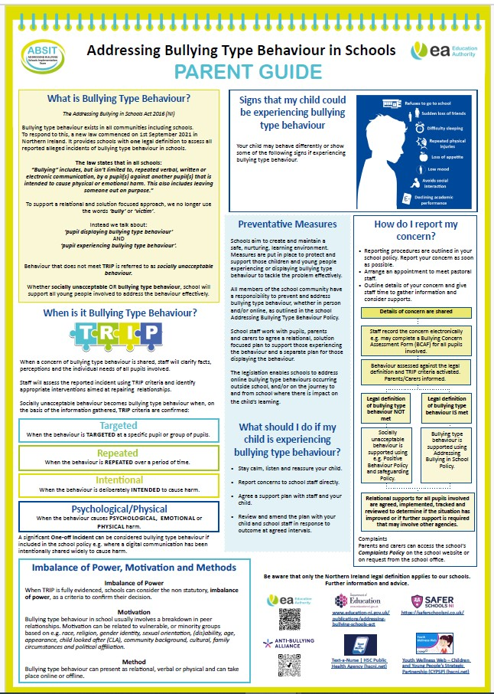
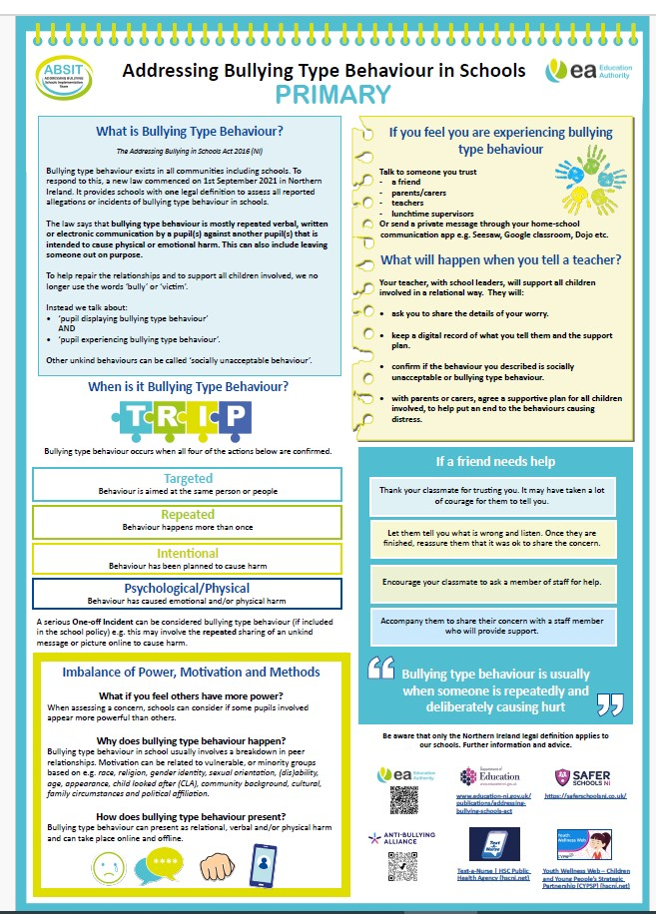

Appendix 7

Addressing Bullying in Schools Act (NI) 2016: Reporting to Board of Governors Pro-forma
Reporting timeframe and date e.g. Term 1 2024-25 ___________________________
Staff member reporting ____________________________ Date of meeting _____________________
Number of allegations of bullying type behaviour
Number of cases that did not meet TRIP criteria
Number of cases that met TRIP criteria
Identified methods of confirmed bullying type behaviour and number of each e.g. Physical - 3
Potential motivation for bullying type behaviour and number of each identified e.g. Racism - 2
Support and interventions in place for both pupils displaying and experiencing bullying type behaviour. (Yes/No)
Emerging trends identified and how these are being responded to.
Areas identified as priority for School Development Planning.

