
Monday News 16th March 2026
Dates for your Diary
Mon 16th – Fri 27th March   | ‘Big Walk & Wheel’Challenge. Children are encouraged to make active journeys to & from school.  Fri 27th Mar: 8.30am: ‘Big Walk & Wheel’ Finale. Walk/Cycle departing Shantallow Shops & Earhart Shop
Mon 16th March   | St Patrick’s Day Celebrations – Children can wear green clothing & accessories & bring in £1 donation for Trocaire. Fun activites throughout the day!  Normal finish time.  ***New Dinner Menu. Week 1 Dinner Menu (Copy on website/paper copies available at Office)  ‘Down Syndrome Awareness Week’  No Credit Union savings this week- savings resume next week  P3’s, P7’s & P5C: Brian Ogs Gaelic - During School
Tues 17th March   | School Closed – St Patrick’s Day Holiday
Wed 18th March | School Closed – St Patrick’s Day Holiday
Thurs 19th March | P4 & P5: Mandarin Lessons – Every Week – During School  Brass Lessons cancelled for next few weeks
Fri 20th March   | Odd Sock Day – chikdren can wear odd socks & bring £1 donation for Foyle Down Syndrome Trust  8.15 – 9am: ‘Breakfast Club Special’ Day . Every Friday  9.10am: Mr Feeney’s P7 Class Assembly.  Families welcome to attend  10.30-12pm: P4 & P5 Foyle Poetry Winners to attend ceremony in Rath Mor Centre
Mon 23rd March | P7 & SPIMS 3 – Swimming Lessons – 10 Weeks  Credit Union Savings for Term 3 resumes
Tues 24th March | 9.15-1.30pm: Nursery trip to Raphoe
Wed 25th March | 12.30 – 3pm: Netball Competition – Templemore Sports Complex
Thurs 26th March | 9.15-11.30am: Nursery to visit Playtrail
Fri 27th March | 8.30am: ‘Big Walk & Wheel’ Walk/Cycle deprting Shantallow Shops & Earhart Shop  9.10am: Mrs Keogh’s P3 Class Assembly.  Families welcome to attend
Sun 29th March | 12.15pm:P4 DTIM Mass - Palm Sunday
Thurs 2nd April | 9.15-11.15am: Middletown Parent Session - Library  All pupils finish at 12.30pm after having lunch.
Fri 3rd – Mon 13th April | Easter Holidays- School Closed  Mon 13th- Staff Development Day. School Closed  All pupils return Tuesday 14th Apr
Tues 14th April | 9.45-1.15pm: Nursery to visit Playtrail
Sat 16th May  | 12 Noon: P4 First Holy Communion – Our lady of Lourdes Church
Mon 15th June | School Closed - Staff Development Day

IMPORTANT: Just2Easy
Please ensure you have downloaded & activated the Parent Portal for Just2Easy before it expires.
(Pupils have a separate Login inside their Homework Diary)
This will be our main means of communication with parents. teachers & school. Our text messaging service is no longer in use for messages such as bumped heads, absences & general messages from teachers. Children will also be set homework on Just 2 Easy.

St Patricks Day celebrations
St Patrick’s Day celebrations will take place on Monday 16th March. We will have a fun filled day with lots of activities including Traditional Music & Irish dancing.
Children can wear green clothing & accessories and asked to bring in £1 donation for Trocaire.


Mr Hargan’s P6 Class Assembly
Thank you to Mr Hargan’s P6 class on their wonderful assembly all about St Patrick, the Patron Saint of Ireland.
It was lovely to have families join us for their assembly.
Thank you
Thank you to Hannah(P2) & her mum for their generous donation towards our Breakfast Club. Your generosity is greatly appreciated. Thank you

Parent Being Well Doing Well Survey
We are very excited to be part of a new programme developed by the Education Authority called ‘Being Well Doing Well’, designed to assist us to develop a Whole School Approach to Emotional Health and Wellbeing.
We would be very grateful if all parents/guardians could take a few minutes to complete the survey, the letter & QR Code explaining in more detail what our survey is about, has been sent out to all parents. Additional copies of the letter are available at the office.
Your opinions will be taken seriously, and we can assure you that all responses are confidential & anonymous.

Punctuality & Early Collections
Children should arrive promptly at school by 9am for registration, lessons begin 9.10am. Arriving late can disrupt the class & impact your child’s learning.



Report an absence/Appointments
If your child is absent from school, please complete the absence report form on our school website before 8.30am on morning of absence.
Early collections can also impact your child’s learning, so we kindly ask that these are avoided where possible.
If your child has an appointment during school, please write a note in their homework diary with reason & time of collection. Pupils will remain in class until parent/guardian arrives at school to collect them. They must be signed out at the office.
Big Walk & Wheel Challenge
As we prepare our bikes, scooters & helmets for our Big Walk & Wheel Week, please remember Electric Scooters are not permitted on school grounds.


Dinner Menu
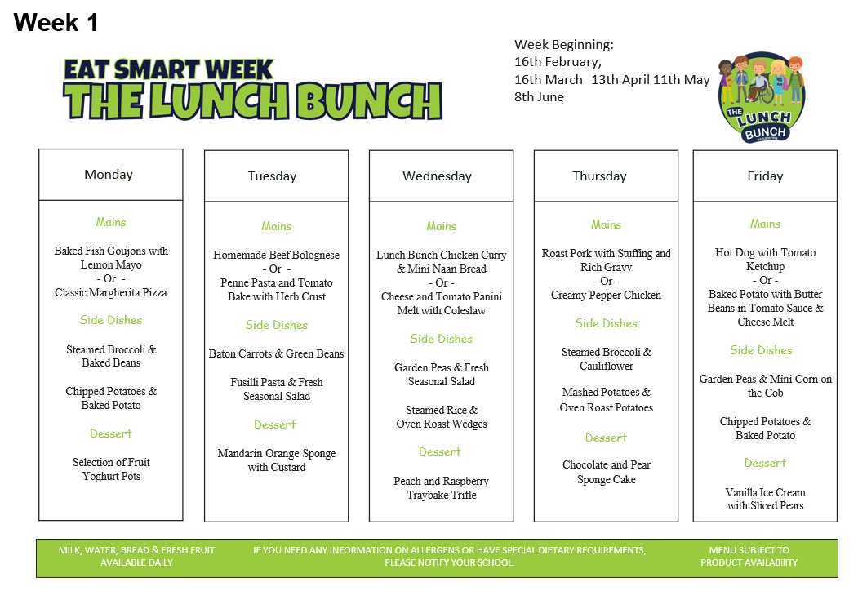
Trócaire
To support our Lenten Trócaire campaign, the children will be taking part in a range of fun activities to help raise money.
Each year group has chosen a different challenge:
- Nursery – Nursery rhyme / fairy tale quiz
- P1 – No Homework Week: Monday 16th March – Friday 20th March
- P2 – No Homework Week: Monday 30th March – Thursday 2nd April
- P3 – Sponsored Soak the Teacher and Danceathon
- P4 – Sponsored No Homework Week
- P5 – Sponsored Sports Fest: Wednesday 1st April
- P6 – Pay to Break the Rules Day
- P7 – Teachers vs. Students football and netball competition
- SPIMS 1, 2 & 3– More details to follow next week

We greatly appreciate your support in helping us raise funds for this very worthy cause.


Crack the Egg
After a successful fundraiser last year ‘Crack the Egg’ draw returns.
Tickets are £3 each or 2 for £5.
One lucky winner will receive half of all monies raised; other half goes directly to school funds.
All children will bring home 2 tickets, please return any unsold/unwanted tickets to class teacher.
Extra tickets are available at the office.
If you’re not in, you can’t win!!!!!


