Monday News 30th March 2026
Dates for your Diary
Sun 29th March | 12.15pm:P4 DTIM Mass - Palm Sunday
Mon 30th March | ***Dinner Menu. Week 3 Dinner Menu (Copy on website/paper copies available at Office)  Credit Union savings day  P3’s, P7’s & P5C: Brian Ogs Gaelic - During School  SPIMS 3, 7A & 7B: Swimming at City Baths during School (10 wks)  3-4pm: Afterschool Choir today (None tomorrow)
Tues 31st March   | P2: Musical Pathways-Every Week- During School  NO Strings Lessons this week  No Afterschool Choir today ( Mon 30th Instead)  Tryatrie - Week 2/4  9.45-12noon: Choir- Feis Competition- Ardnsahee School
Wed 1st April   | P3A & P5: Na Magha- Hurley – Every Week -During School  P7 Trócaire Fundraiser- during school  Special Canteen Menu – Sausages & Chips ( All pupils taking dinner will be enetred into a draw to win Easter eggs in Canteen)
Thurs 2nd April | P4 & P5: Mandarin Lessons – Every Week – During School  No Brass Lessons this week  Grand Draw for ‘Crack the Egg’/Easter Hampers/ Class Easter Eggs  9.15-11.15am: Middletown Parent Session - Library  All pupils finish at 12pm – ( Breakfast Club on/No lunch today)  (11.55am: Collection P1-P4)  (12 Noon: P5-P7)  7pm: P4 DTIM Mass- Holy Thursday Mass of the Last Supper. Our Lady of Lourdes
Fri 3rd – Mon 13th April   | Easter Holidays- School Closed  Mon 13th- Staff Development Day. School Closed  All pupils return Tuesday 14th Apr
Tues 14th April | 9.45-1.15pm: Nursery to visit Playtrail
Wed 15th Apr | Jazz festival participants to visit school  7pm: Smartphone Information Session- Shantallow Community Centre. Parents encouraged to attend
Thurs 16th Apr | 10am: Whole School Mass  Community Bingo- More details to follow
Wed 22nd Apr | 12.30-3pm: Netball Competition/No Netball Afterschool Club
Fri 24th Apr | 9.10am: Mrs Cooke’s P2 class Assembly. Families welcome to attend
Sat 16th May  | 12 Noon: P4 First Holy Communion – Our lady of Lourdes Church
Mon 15th June | School Closed - Staff Development Day

Parent Being Well Doing Well Survey
We would be very grateful if all parents/guardians could take a few minutes to complete the survey if they haven’t already done so.

Big Walk & Wheel Challenge
Thank you & well done to all our boys & girls along with their families that made active journeys to school by either walking, wheeling, scooting or cycling as part of Sustrans ‘Big Walk & Wheel’ Challenge.


Congratulations & Well Done
We would like to commend Aiden P6A Mr Hargan’s Class for his outstanding swimming at the Swim Ulster Future Challengers Gala in Lisburn at the weekend, where he achieved his 3 PB's representing City of Derry Swim Team.
Dinner Menu
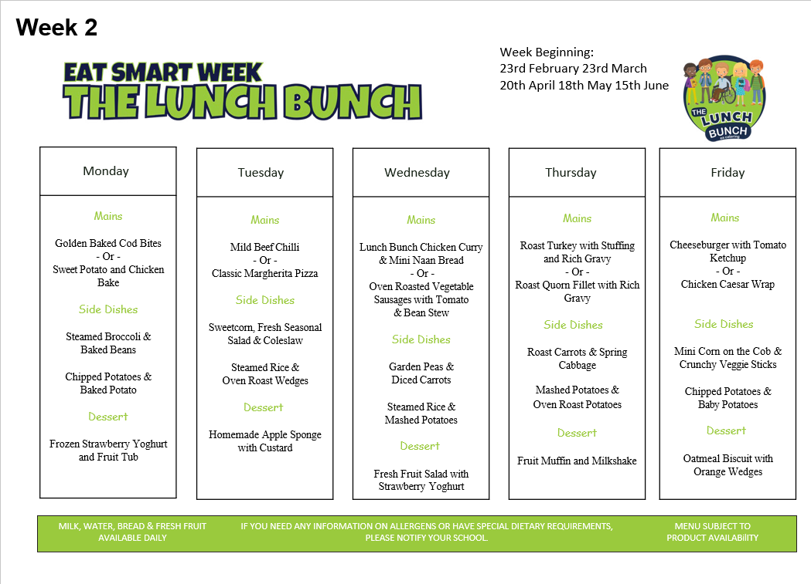
Trócaire
To support our Lenten Trócaire campaign, the children will be taking part in a range of fun activities to help raise money.
Each year group has chosen a different challenge:
- Nursery – Nursery rhyme / fairy tale quiz
- P2 – No Homework Week: Monday 30th March – Thursday 2nd April
- P3 – Sponsored Soak the Teacher and Danceathon
- P4 – Sponsored No Homework Week 30th March – Thursday 2nd April
- P5 – Sponsored Sports Fest: Wednesday 1st April
- P6 – Pay to Break the Rules Day
- P7 – Teachers vs. Students football and netball competition. Wed 1st April

We greatly appreciate your support in helping us raise funds for this very worthy cause.

Crack the Egg
After a successful fundraiser last year ‘Crack the Egg’ draw returns.
Tickets are £3 each or 2 for £5.
One lucky winner will receive half of all monies raised; other half goes directly to school funds.
Extra tickets are available at the office. Draw will be held Thurs 2nd April.
If you’re not in, you can’t win!!!!!

Easter Hamper
Steelstown P.S & Nursery Unit Easter Raffle will take place on Wed 1st April. Tickets are on sale each morning at the foyer 8.30 - 9am. Tickets are 50p each.
All monies raised will go towards school funds.
All children will also be entered into a FREE class draw for an Easter egg.
Thank you to Carter(P3) & Maddison’s (P6) Granny for her kind donation of a beautiful Easter Hamper for our Raffle.
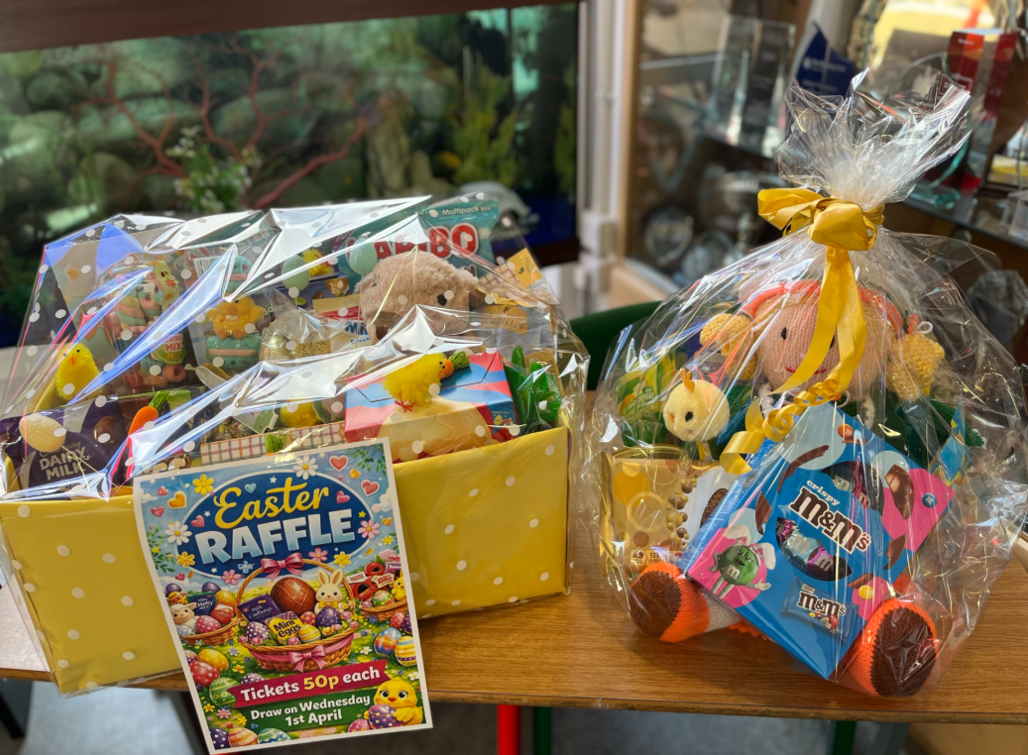

Friends of Steelstown – Volunteers needed
We are seeking volunteers to join ‘Friends of Steelstown’ and help establish a small working group to support upcoming fundraising events — including BINGO!
It’s a great way to get involved, meet others, and have fun. If you or someone you know would like to join, please contact the school office. Participation is open to all friends of Steelstown, not just carers and families. Please contact the office if you would like to Volunteer.

