Monday News 11th May 2026
Dates for your Diary
Mon 11th May   | Week 1 Dinner Menu  Credit Union savings day  P3’s, P7’s & P5C: Brian Ogs Gaelic - During School  SPIMS 3, 7A & 7B: Swimming at City Baths during School (10 wks)  1.15pm: Familes Connect- P2 Mobile Huts
Tues 12th May   | P1: Musical Pathways-Every Week- During School  1-4pm: Girls Football Team- Bay Road. Please collect from Bay Road  3-4pm: P6 Transfer Club- Every Tues & Thurs
Wed 13th May   | P3A & P5: Na Magha- Hurley – Every Week -During School  1.30-3pm: Parents Workshop with Numerasee- Hall  2-3pm: P7 Cycling Profiencey Course (Week 6/12)  Bike & Helmet needed each week  2.30pm: Nursery Stay & Play Session- COHORT 1
Thurs 14th May | P4 & P5: Mandarin Lessons – Every Week – During School  2.30pm: Nursery Stay & Play Session- COHORT 2  3-4pm: P6 Transfer Club- Every Tues & Thurs
Fri 15th May | 8.15-9am: ‘Breakfast Club Special’ Every Friday
Sat 16th May   | 12 Noon: P4 First Holy Communion – Our lady of Lourdes Church. Photographer available before & after mass.  There will be no access to chapel before 11.30am
Mon 18th May | P1 Sports Day - weather permitting
Tues 19th May | P2 Sports Day - weather permitting  2.30pm: Nursery Stay & Play Session- COHORT 3
Wed 20th may | P3 Sports Day - weather permitting  2.30pm: Nursery Stay & Play Session- COHORT 4
Thurs 21st May | P4 Sports Day - weather permitting
Fri 22nd May | 9.10am: Mrs Tierney’s P4 Class Assembly
Mon 25th - Fri 29th May | School Closed- May Holiday
Fri 5th June | 9.10am: Mrs Warren’s P2 Class Assembly  10 – 1.30pm: P7 Fan the Flame Mass
Sun 7th June | 12.15pm: P4 DTIM Mass- Corpus Christi
Wed 10th June | P5-P7 Sports Day: Brian Og’s- Weather permitting
Thurs 11th June | NWSSA- Swim Gala- City Baths
Mon 15th June | School Closed - Staff Development Day
Wed 17th June | 9.15-11.30am: Nursery- visit Playtrail, Forest Schools  2pm: P7 Leavers Mass, Our Lady of Lourdes Church
Tues 30th June | Non-uniform day & 12.30pm finish for all pupils
Report an Absence
Our Absence Reporting form on the school website is currently unavailable. If your child will be absent from school, please report it by replying to the Text Message System to ensure your child’s attendance is recorded correctly.

P4 First Communion Photos
The school photographer will be available to take individual & family photos outside Our Lady of Lourdes on Sat 16th May from 11am and after the ceremony. No appointment necessary.
A class photograph will be taken on the altar at the end of the ceremony. Please only have photos taken if you are committed to purchasing them. Thank you for your understanding.
E-Sports Wed’s P4-P7
There are a few spaces left on E- Sports After school club from 3.05-4pm every Wednesday for P4-P7 pupils.
If you would like your child to attend, please complete the Afterschool Permission Form on the School Website.
Places are on a first come basis due to limited numbers and you can only sign up using the online form.

Sports Day
Please note dates are provisional/weather permitting & subject to change
Date | Time | Year
Mon 18th May | 9.30-11.45am | P1
Tues 19th May | 9.45-11.45am | P2
Wed 20th May | 9.30-11.45am | P3
Thurs 21st May | 10am-11.45am | P4
Wed 10th June | TBC | P5-P7 Brian Og’s Gaelic Pitch

End of year trips
All pupils will receive a permission note for their end of year trip in the coming weeks. Please return the permission slip & monies to class teacher.
Nursery | 25th June | We love 2 party
P1 | 18th June | Oakfield Park, Raphoe
P2 | 18th June | Lurgybrack Farm, Letterkenny
P3 | 16th June | Wild Ireland
P4 | 19th June | Leisureland, Redcastle
P5 | 24th June | Lock ‘N’ Load
P6 | 22nd June | Lifford Courthouse
P7 | 22-24th June | Carlingford
Numeracy Parent Workshop
Would you like to support your child’s learning in maths?
Join us for our upcoming Numeracy Workshop delivered in partnership with Katrina from Numerasee. Please return your attendance slip when you receive it to secure your place!
We strongly encourage all parents to attend this informative and practical session – it’s a great opportunity to pick up tips and ideas to support your child at home.

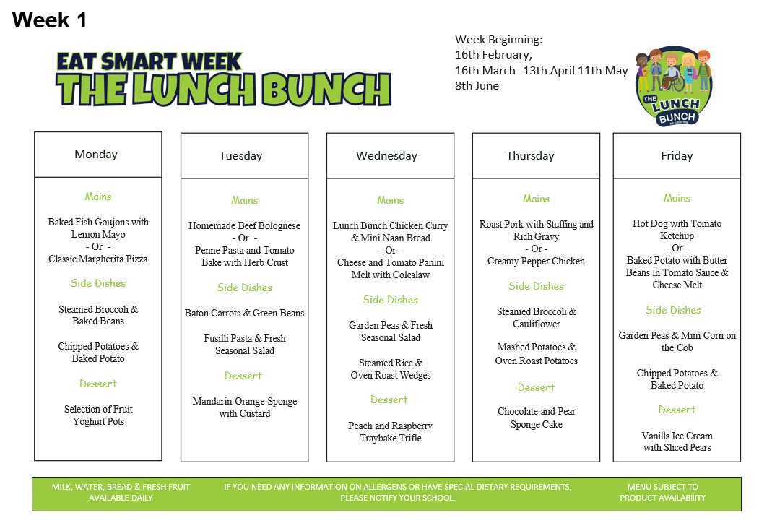
Post Primary Outcome
If you are awaiting the outcome of your child’s Post Primary application, you will receive notification this Saturday, 9 May.
If you applied online or provided an email address on your paper application, you will receive an email from EA.
Paper applicants who did not provide an email address, will receive a letter to their home address.
Parents who have a child with a Statement of Special Educational Needs awaiting placement will be updated by their SEN link officer when a placement has been secured. This process may take a little longer as we work to find the best placement for your child’s needs.
For further information, please visit: https://ow.ly/jBK950VKjJb
