Monday News 25^{h} May 2026
Dates for your Diary
Mon 25th-fri 29th May | School Closed- May Holiday 
Mon 1st June   | Week 4 Dinner Menu  P7 Show: Remaining Tickets on sale. £5 Each. First come basis  Credit Union savings day (2 weeks remaining)  St Cecilia’s College to visit P7 Girls  P3’s, P7’s & P5C: Brian Ogs Gaelic - During School  SPIMS 3, 7A & 7B: Swimming at City Baths during School (10 wks)  1.15pm: Familes Connect- P2 Mobile Huts
Tues 2nd June   | P1: Musical Pathways-Every Week- During School  10-12pm: P1 Sports Day (Weather permitting)  3-4pm: P6 Transfer Club- Every Tues & Thurs
Wed 3rd June   | P3A & P5: Na Magha- Hurley – Every Week -During School  2-3pm: P7 Cycling Profiencey Course (Week 8/12)  Bike & Helmet needed each week  7pm: P7 School Show (Tickets £5 each, available from office)
Thurs 4th June | P4 & P5: Mandarin Lessons – Every Week – During School  10-1.15pm:P7 ‘Fan the Flame’ Mass  10am: Whole School Mass- P1-P6  3-4pm: P6 Transfer Club- Every Tues & Thurs
Fri 5th June | 8.15-9am: ‘Breakfast Club Special’ Every Friday  9.10am: Mrs Warren’s P2 Class Assembly  Families welcome to attend  9.30-12.30pm: P7 Love for Life Programme
Sun 7th June | 12.15pm: P4 DTIM Mass- Corpus Christi
Mon 8th June | P6 End of Year Literacy Assessments. Attendance is important  Final day for Credit Union savings- please return pouch even if you are not saving so monies saved can be tallied.
Tues 9th June | P5 End of Year Literacy Assessments. Attendance is important
Wed 10th June | P4 End of Year Literacy Assessments. Attendance is important  P5-P7 Sports Day: Brian Og’s- Weather permitting
Thurs 11th June | NWSSA- Swim Gala- City Baths  Girls Gaelic All County Finals  P7 End of Year Literacy Assessments. Attendance is important
Mon 15th June | School Closed - Staff Development Day
Wed 17th June | 9.15-11.30am: Nursery- visit Playtrail, Forest Schools  2pm: P7 Leavers Mass, Our Lady of Lourdes Church followed by BBQ in school (Max 4 guests)
Thurs 18th June | Am: P7 Pupils Awards (Pupils Only) followed by Brunch in canteen
Fri 19th June | 9-2pm: P7 pupils to attend St Cecilia’s, St Brigid’s College St Marys College & Oakgrove for induction
Wed 24th June | Final day for P7 pupils
Tues 30th June | Non-uniform day & 12.30pm finish for all pupils

Important Reminder
In the interest of pupil safety, pupils should not arrive to school before 8.15am. Pupils arriving at 8.15am must go to Breakfast Club, outside supervision begins at 8.30am in your child’s designated area. Thank you for your cooperation.
School Summer Scheme
Parent/Guardians will receive communication start of June for expression of interest for School Summer Scheme.
Report an Absence
If your child will be absent from school for any reason, please report their absence daily via the ‘Absence Report Form’ on our school website to ensure your childs absence is recorded correctly. You may also be contacted by the school if no reason for absence is received, please reply to absence text to ensure reason for absence is recorded for your child.
If your child needs to be collected during the school, please send a note to your childs class teacher the day previous or morning of appointment. Where possible, please keep appointments to outside school hours. Thank you for your support.

P7 Show
This year our Primary 7 pupils are proud to announce their end of year show ‘Gigglebox’ on Wed 3rd June at 7pm.
Tickets are on sale at the office priced at £5 each. Parents/Guardians have had the opportunity to purchase up to 3 tickets.
On Monday 1st June all remaining tickets are available on a first come first served basis.
Please ensure you secure your tickets as there is only one performance!

End of Year Assessments – Important Information
Numeracy Testing will resume Mon 8th June and will conclude on Friday 19th June.
Assessment Arrangements

- P1 & P2 – Children will complete a combination of individual and group written tasks, as well as practical activities.
- P3 – Pupils will take written standardised assessments in English and Mathematics.
- P4–P7 – Pupils will complete CCEA digital standardised assessments in English and Mathematics (see dates below).
We kindly ask that you make every effort to ensure your child attends school each day during this period. These assessments help us measure your child’s progress and inform future teaching and learning.
Information gathered during these tests will be included in your child’s Annual School Report, which will be issued in June.
Thank you for your continued support.
CCEA Assessment Timetable
Numeracy Date | Year Group
Monday 8th June | P6
Tuesday 9th June | P5
Wednesday 10th June | P4
Thursday 11th June | P7


Sports Day
Please note dates are provisional/weather permitting & subject to change
Date | Time | Year
Tues 2nd June (Weather permitting) | 10-12noon | P1
New date to be announced | 9.45-11.45am | P2
New date to be announced | 10am-11.45am | P4
Wed 10th June | 10am | P5-P7 Brian Og’s Gaelic Pitch


End of year trips
All pupils will receive a permission note for their end of year trip.
Please return the permission slip & monies to class teacher.
Nursery | 25th June | We love 2 Party
P1 | 18th June | Oakfield Park, Raphoe
P2 | 18th June | Lurgybrack Farm, Letterkenny
P3 | 16th June | Wild Ireland
P4 | 19th June | Leisureland, Redcastle
P5 | 24th June | Lock ‘N’ Load
P6 | 22nd June | Lifford Courthouse
P7 | 22-24th June | Carlingford

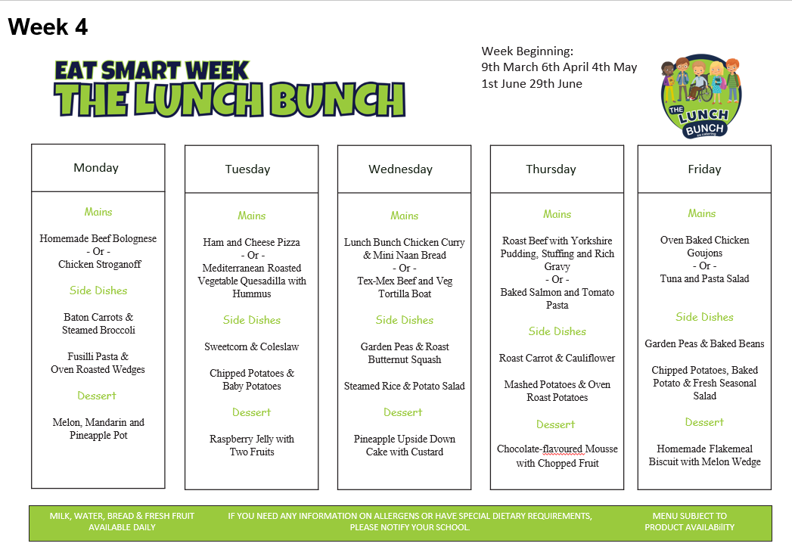
Rhythm and Rhyme
Young children are warmly invited to join Rhythm and Rhyme sessions every Thursday morning from 10.45-11.30am at Shantallow Library. These fun and engaging sessions are perfect for younger brothers and sisters of our pupils, offering songs, rhymes, and actions that help develop an awareness of rhythm and sound. By listening to and joining in with rhymes, children build important early language skills that support their journey into reading. It’s also a lovely opportunity to enjoy music, movement, and storytelling in a friendly and welcoming environment.



