Monday News 8th June 2026
Dates for your Diary
Sun 7th June | 12.14pm: P4 DTIM Mass- Corpus Christi
Mon 8th June   | Dinner menu Week 1: Please note change to today’s Dinner menu: Ocean World  P6 End of Year Literacy Assessments. Attendance is important  Week 1 Dinner Menu  Credit Union savings day (Final week, return savings pouch even if not saving)  SPIMS 3, 7A & 7B: Swimming at City Baths during School (Final Week)
Tues 9th June   | P5 End of Year Literacy Assessments. Attendance is important  P1: Musical Pathways-Every Week- During School  2-3pm: P6 SEAG Parent Meeting
Wed 10th June   | P4 End of Year Literacy Assessments. Attendance is important  P5-P7 Sports Day: Brian Og’s- Weather permitting  P3A & P5: Na Magha- Hurley – Every Week -During School  2-3pm: P7 Cycling Profiencey Course (Week 9/12)  Bike & Helmet needed each week ( Cancelled if Sports Day goes ahead)
Thurs 11th June | P7 End of Year Literacy Assessments. Attendance is important  9.30-12.45pm: NWSSA- Swim Gala- City Baths  Girls Gaelic All County Finals  P4 & P5: Mandarin Lessons – Every Week – During School
Fri 12th June | P7 Leavers photo in Derry Journal  8.15-9am: ‘Breakfast Club Special’ Every Friday  9.10am: P1 Assembly. Families welcome to attend  Whole School Zumbathon- All pupils have received a sponsor form.
Mon 15th June | School Closed - Staff Development Day
Wed 17th June | 9.15-11.30am: Nursery- visit Playtrail, Forest Schools  2pm: P7 Leavers Mass, Our Lady of Lourdes Church followed by BBQ in school (Max 3 guests)
Thurs 18th June | Final Day of Afterschool Clubs (with the exception of P1 & P2 Afterschool Club & Wraparound Club, which run until Mon 29th June)  Am: P7 Pupils Awards (Pupils Only) followed by Special Brunch in canteen
Fri 19th June | 9-2pm: P7 pupils to attend St Cecilia’s, St Brigid’s College St Marys College & Oakgrove for induction
Wed 24th June | Final day for P7 pupils
Tues 30th June | Non-uniform day & 12.30pm finish for all pupils
School Summer Scheme
Parent/Guardians will receive communication soon for expression of interest for School Summer Scheme.
Credit Union Savings Scheme
The final day for credit union savings in Monday 8th June.
Please return all savings cards -whether your child is saving that day or not, to enable the credit union to tally the cards & process the cash payments. Savings will be returned in cash to each child with their savings card the following week.
The credit Union would like to thank you & your child for your support and regular savings this year. Your support in the form of encouraging your child to save regularly will make a positive difference in their attitude towards saving and their future financial wellbeing.

After School Clubs
After School clubs finish Thursday 18th June, except for P1 & P2 Afterschool club & Wraparound Care Club which finish Mon 29th June.

ParentPay
Please ensure your ParentPay account is up to date and all payments for meals, swimming, P1 & P2 Afterschool club & wraparound Care are settled before the end of term.

Sports Day
Please note dates are provisional/weather permitting & subject to change
Date | Time | Year
New date to be announced | 10-12noon | P1
New date to be announced | 9.45-11.45am | P2
New date to be announced | 10am-11.45am | P4
Wed 10th June (Weather Permitting) | 10am | P5-P7 Brian Og’s Gaelic Pitch

P7 Show
A huge well done to all our Primary 7 boys & girls on their amazing performance in the school show! Your hard work, creativity, and confidence truly shone on stage. You should be incredibly proud of everything you’ve achieved—you entertained, inspired, and made lasting memories.
Well done to the cast and the staff on a wonderful performance, it was amazing!
Please see our Website & Facebook page for videos & photos.
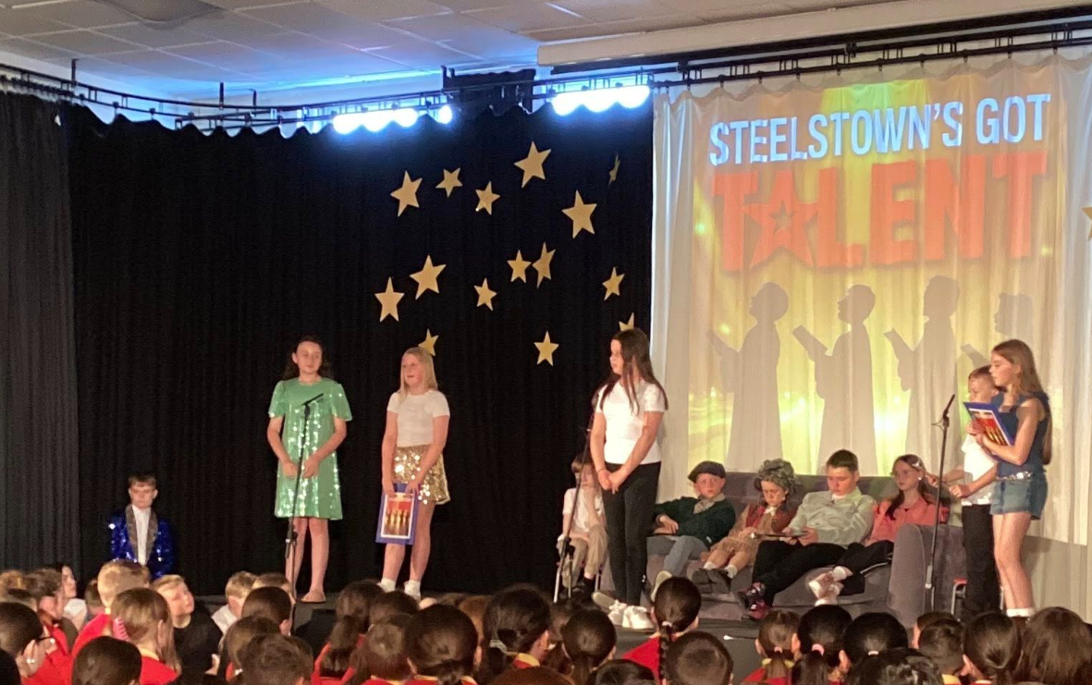
Fan the Flame
Today was a truly special and memorable day for our P7 pupils as they attended their Fan the Flame Mass at Celtic Park. A wonderful experience filled with joy, reflection, and celebration!

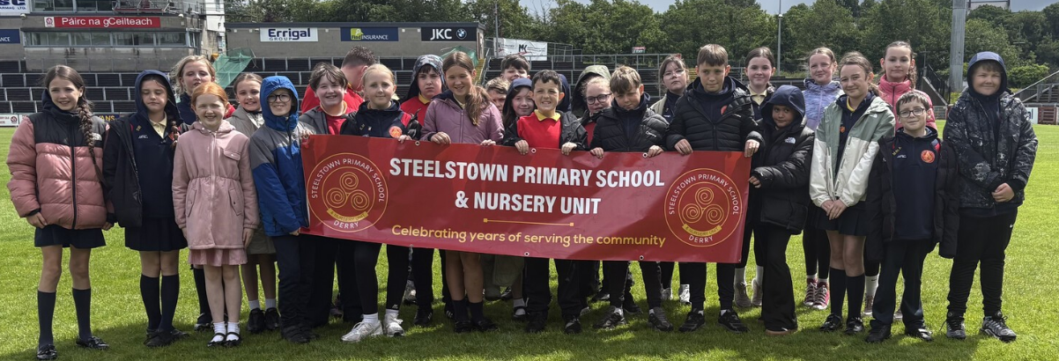
End of Year Assessments – Important Information
Numeracy Testing will resume Mon 8th June.
Assessment Arrangements
- P4–P7 – Pupils will complete CCEA digital standardised assessments in English and Mathematics (see dates below).

We kindly ask that you make every effort to ensure your child attends school each day during this period. These assessments help us measure your child’s progress and inform future teaching and learning.
Information gathered during these tests will be included in your child’s Annual School Report, which will be issued in June.
Thank you for your continued support.
CCEA Assessment Timetable
Numeracy Date | Year Group
Monday 8th June | P6
Tuesday 9th June | P5
Wednesday 10th June | P4
Thursday 11th June | P7


End of year trips
All pupils will receive a permission note for their end of year trip.
Please return the permission slip & monies to class teacher.
Nursery | 25th June | We love 2 Party
P1 | 18th June | Oakfield Park, Raphoe
P2 | 18th June | Lurgybrack Farm, Letterkenny
P3 | 16th June | Wild Ireland
P4 | 19th June | Leisureland, Redcastle
P5 | 24th June | Lock ‘N’ Load
P6 | 22nd June | Lifford Courthouse
P7 | 22-24th June | Carlingford

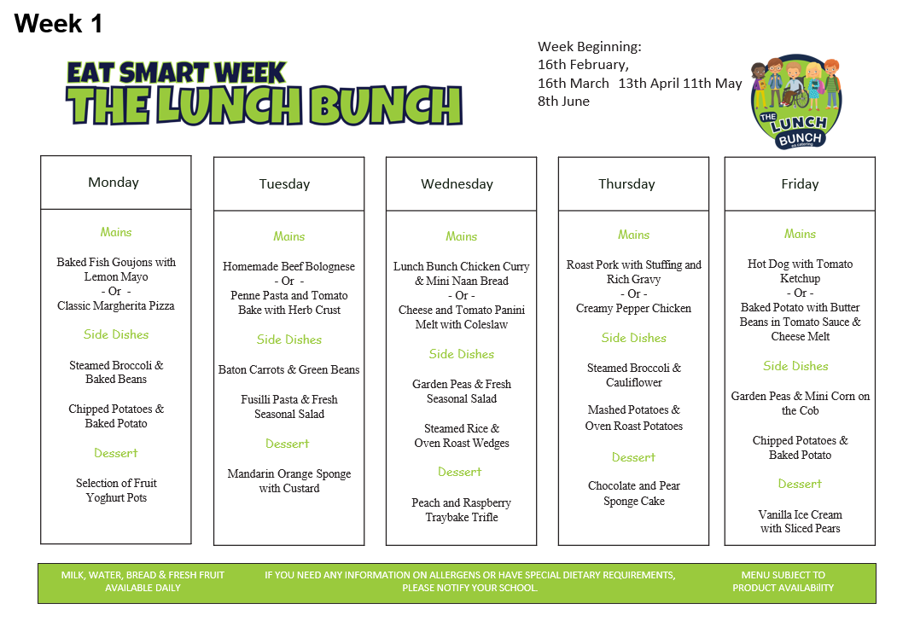
Mondays Ocean World Menu

Rhythm and Rhyme
Young children are warmly invited to join Rhythm and Rhyme sessions every Thursday morning from 10.45-11.30am at Shantallow Library. These fun and engaging sessions are perfect for younger brothers and sisters of our pupils, offering songs, rhymes, and actions that help develop an awareness of rhythm and sound. By listening to and joining in with rhymes, children build important early language skills that support their journey into reading. It’s also a lovely opportunity to enjoy music, movement, and storytelling in a friendly and welcoming environment.




Free School Meals & Uniform Allowance
Applications for Free School Meals and Uniform Allowance for the upcoming academic year are now open!
Apply now: https://connect.eani.org.uk/parent/
Please note, as well as new applicants, parents/carers of children who are currently in receipt of Free School Meals and Uniform Allowance will need to apply again for the 2026/27 school year.
If you don’t already have an EA Connect account, you will need to set one up. This is quick and easy to do, and there is lots of helpful information available on www.eani.org.uk/fsm to show you how.
You will also find details on eligibility and the supporting documentation you will need to upload when making your application.
Entitlement cannot be back dated so please ensure you apply in plenty of time for them to be in place for 1st Sept.

