Monday News 15th June 2026
Dates for your Diary
Mon 15th June | School closed to all pupils - Staff Development Day
Tues 16th June | Week 2 Dinner Menu  9.45-1pm: P5-P7 Sports Day at Brian Og Pitches.  Canteen will deliver Sausages & Chips to pitch for those taking dinners. Tea/Coffee & Traybakes available for parents.  P1: Musical Pathways-Every Week- During School  P3: School Trip – Wild Ireland
Wed 17th June | 9.15-11.30am: Nursery- visit Playtrail, Forest Schools  9.30-11.30am: P1 Sports Day  2pm: P7 Leavers Mass, Our Lady of Lourdes Church followed by BBQ in school (Max 3 guests)
Thurs 18th June | 10-11.45am: P4 Sports Day  P4 & P5: Mandarin Lessons – Every Week – During School  Final Day of Afterschool Clubs (except for P1 & P2 Afterschool Club & Wraparound Club, which run until Mon 29th June)  Am: P7 Pupils Awards followed by Special Brunch in canteen (Pupils Only)
Fri 19th June | P7 pupils to attend St Cecilia’s, St Mary’s, St Brigid’s College & Oakgrove for induction  P4 School Trip – Leisureland, Redcastle  8.15-9am: ‘Breakfast Club Special’ Every Friday  9.45-11.45am: P2 Sports Day
Mon 22nd June | 9.15am: P7 pupils Carligford Trip (Mon-Wed)  **Pupils not attending Carlingford to attend school Mon-Wed***  SPIMS 1, 2 & 3 School Trip – We love 2 Party  P6 School trip – Lifford Courthouse
Wed 24th June | P5 School Trip – Lock ‘N’ Load  P7: Final day for pupils not attending Carlingford
Thurs 25th June | Nursery School Trip – We love 2 Party
Fri 26th June | 10am: Nursery Graduation.  End of Year Reports will be sent home
Mon 29th June | Superhero Themed Day  8.30-10am: Daibhin’s Superhero Coffee Morning  Special Themed Superhero menu in Canteen. All Pupils can dress as superheroes & bring £1 donation for Daibhin’s charity.
Tues 30th June | Non-uniform day & 12.30pm finish for all pupils
School Summer Scheme
Thank you to everyone who expressed interest for our School Summer Scheme. Expression of Interest has now closed.
Those who have secured a place will be notified before Fri 19th June.
Credit Union Savings Scheme
Credit Union savings are due to be returned to school Week Beginning Mon 15th June. Text message will be sent to inform parents/guardians which day your child will bring home their savings.
The credit Union would like to thank you & your child for your support and regular savings this year. Your support in the form of encouraging your child to save regularly will make a positive difference in their attitude towards saving and their future financial wellbeing.

After School Clubs
After School clubs finish Thursday 18th June, except for P1 & P2 Afterschool club & Wraparound Care Club which finish Mon 29th June.

ParentPay
Please ensure your ParentPay account is up to date and all payments for meals, swimming, P1 & P2 Afterschool club & wraparound Care are settled before the end of term.

Nursery Graduation
A Photographer will attend our Nursery graduation on Friday 26th June. Parents/Guardians will be given a ticket/QR code to order their photos online.
P1 Assembly
Well done to all the boys and girls in Primary One on their very first assembly at Steelstown P.S.! I'm sure all parents will agree that the children were absolutely wonderful. It was lovely to see so many parents and guardians join us for this special occasion.


School Books
Please ensure to return all reading books, library books & textbooks to the school. If you find books belonging to school that you have from previous years, we’d be delighted to have those back too.
Every schoolbook is important to us!

Lost property
All items from Lost Property will be available to view each morning until 9am at reception. Please check when passing in case your child has misplaced any coats, lunchboxes, water bottles etc throughout the year.

Sports Day
Please note dates are weather permitting & subject to change
Date | Time | Year
Wed 17th June | 9.30-11.30am | P1
Fri 19th June | 9.45-11.45am | P2
Thurs 18th June | 10am-11.45am | P4
Tues | 9.45-1pm | P5-P7 Brian Og’s Gaelic Pitch

End of year trips
All pupils will receive a permission note for their end of year trip.
Please return the permission slip & monies to class teacher.

Nursery | 25th June | We love 2 Party
P1 | 18th June | Oakfield Park, Raphoe
P2 | 18th June | Lurgybrack Farm, Letterkenny
P3 | 16th June | Wild Ireland
P4 | 19th June | Leisureland, Redcastle
P5 | 24th June | Lock ‘N’ Load
P6 | 22nd June | Lifford Courthouse
P7 | 22-24th June | Carlingford

City of Derry Triathlon
Please inform school office if you register your child via Eventbrite to take part in City of Derry Triathlon.
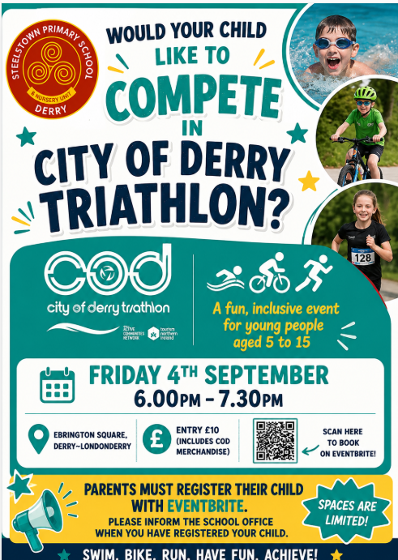



Free School Meals & Uniform Allowance
Applications for Free School Meals and Uniform Allowance for the upcoming academic year are now open!
Apply now: https://connect.eani.org.uk/parent/
Please note, as well as new applicants, parents/carers of children who are currently in receipt of Free School Meals and Uniform Allowance will need to apply again for the 2026/27 school year.
If you don’t already have an EA Connect account, you will need to set one up. This is quick and easy to do, and there is lots of helpful information available on www.eani.org.uk/fsm to show you how.
You will also find details on eligibility and the supporting documentation you will need to upload when making your application.
Entitlement cannot be back dated so please ensure you apply in plenty of time for them to be in place for 1st Sept.

