Monday News 29th June 2026
Dates for your Diary
Mon 29th June | Superhero Themed Day/Fun Day/ Summer Party  Special Themed Superhero menu in Canteen. (See bulletin for menu)  All Pupils can dress as superheroes/own clothes & bring £1 donation for Daibhin’s charity.  8.30-10am: Daibhin’s Superhero Coffee Morning in canteen, everyone welcome
Tues 30th June | Non-uniform day & 12.30pm finish for all pupils after having lunch.  Canteen Menu: Sausage & Chips  There will be no bus service at 12.30pm.
Wed 1st- Fri 3rd July | 9-12.30pm: School Summer Scheme  (Mid-Morning snack will be provided)
Tues 1st Sept | School Term resumes for P2-P7 Children  9.10 – 3.05pm (P2 2.15pm finish)  Nursery & P1 pupils- allocated start dates & times

Dear Parents, Carers and Staff,
As we come to the end of another very successful year at Steelstown Primary School, I would like to take this opportunity to thank our entire school community.
Thank you to our dedicated staff for their hard work, commitment, and care throughout the year. Thank you to our parents and carers for your continued support and partnership—it makes such a difference to our school.
Most importantly, I want to congratulate our wonderful boys and girls. They have achieved so much this year across learning, sport, the arts and in their personal development. We are incredibly proud of every one of them and all they have accomplished.
A special well done on the school reports—these reflect the effort, progress and achievements we have seen throughout the year.
Our school Holiday list will be available on our website in the coming weeks.
I would like to stress the importance of ensuring that pupils are not taken out of school during term time. Family holidays should be planned during designated school holiday periods only.
Finally, I wish you all a safe, happy and restful summer. We look forward to welcoming everyone back for another exciting year ahead.
Kind regards,
Catherine Doorish

All children finish on Tuesday 30thJune at 12.30pm
End of Year Reports
All pupils received their end of year reports to take home on Friday. Well done to all pupils on their hard work this year. The boys & girls also got to meet their new teachers today
Nursery Graduation
Congratulations to all our Nursery children who graduated on Friday!
We had a lovely ceremony celebrating everything they have achieved during their year at Steelstown Nursery, and we are incredibly proud of each and every one of them.
Photos can be ordered online via the QR code given by photographer.
We look forward to seeing the boys & girls again in September as they begin the next stage of their journey.

ParentPay
Please ensure your ParentPay account is up to date and all payments for meals, swimming, P1 & P2 Afterschool club & wraparound Care are settled before the end of term or they will carry over to next year.
P7 Carlingford Trip
Our P7 boys and girls had a memorable trip to Carlingford, enjoying a fantastic range of outdoor activities and team-building games. It was a wonderful way to mark the end of their time at Steelstown Primary School.
Ms. Doorish would like to commend all the children for their excellent behaviour throughout the trip—they were a credit to both the school and their families.
We wish them every success and happiness as they move on to their new schools!
Please visit our website/Facebook to see more photos from their trip.
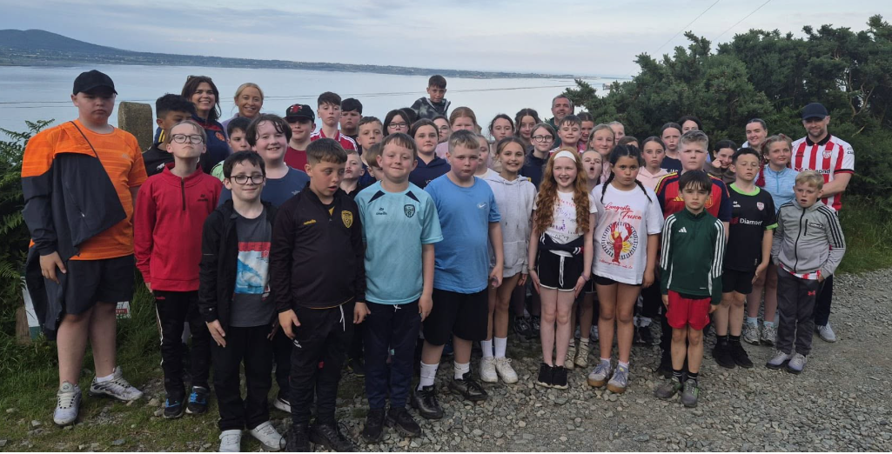

Free School Meals & Uniform Allowance
Applications for Free School Meals and Uniform Allowance for the upcoming academic year are now open, please ensure you apply before 31st July to ensure entitlement is in place for 1st September!

Apply now: https://connect.eani.org.uk/parent/
Please note, as well as new applicants, parents/carers of children who are currently in receipt of Free School Meals and Uniform Allowance will need to apply again for the 2026/27 school year.

If you don’t already have an EA Connect account, you will need to set one up. This is quick and easy to do, and there is lots of helpful information available on www.eani.org.uk/fsm to show you how.
You will also find details on eligibility and the supporting documentation you will need to upload when making your application.
Entitlement cannot be back dated so please ensure you apply before 31st July in plenty of time for them to be in place for 1st Sept.
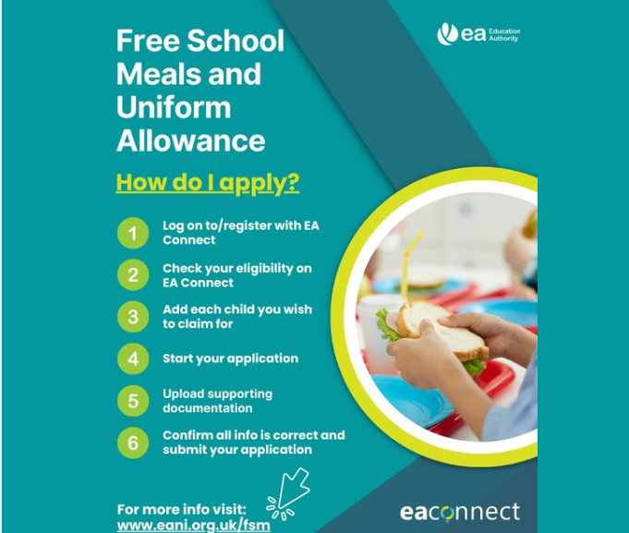
Coffee Morning - Monday 29th June
We are holding a Coffee Morning on Monday 29th June from 8.30am -10am in our canteen, in honour of our Superhero Dáibhín. Please come along & show your support.
All pupils can also come to school dressed as superheroes/own clothes & bring in £1 donation for Dáibhín’s chosen charity – ICU Unit, Royal Victoria Hospital Belfast.
Canteen is providing a special ‘Superhero’ Themed dinner on Monday too. Please see menu below.
All pupils will also have a fun day throughout the day including Bouncy Castles & fun classroom activities.


Superhero menu will be served Mon 29th June
